AR MARKER BASED LENGTH MEASUREMENT APP

ERIC CHIA TECK HAN

SESSION 2018/2019

FACULTY OF COMPUTING AND INFORMATIC

MULTIMEDIA UNIVERSITY

FEBRUARY 2019

AR MARKER BASED LENGTH MEASUREMENT APP

BY

ERIC CHIA TECK HAN

SESSION

2018/2019

THE PROJECT REPORT

IS PREPARED FOR

FACULTY OF COMPUTING AND INFORMATICS

MULTIMEDIA UNIVERSITY

IN PARTIAL FULFILLMENT

FOR

BACHELOR OF COMPUTER SCIENCE

B.CS (HONS) SOFTWARE ENGINEERING

FACULTY OF COMPUTING AND INFORMATICS

MULTIMEDIA UNIVERSITY

FEBRUARY 2019

Copyright of this report belongs to Universiti Telekom Sdn. Bhd. as qualified by Regulation 7.2 (c) of the Multimedia University Intellectual Property and Commercialisation Policy. No part of this publication may be reproduced, stored in or introduced into a retrieval system, or transmitted in any form or by any means (electronic, mechanical, photocopying, recording, or otherwise), or for any purpose, without the express written permission of Universiti Telekom Sdn. Bhd. Due acknowledgement shall always be made of the use of any material contained in, or derived from, this report.

© 2018 Universiti Telekom Sdn. Bhd. ALL RIGHTS RESERVED.

**DECLARATION**

I hereby declare that the work has been done by myself and no portion of the work in this thesis has been published in any application from any other degree, qualification, other university or institute of learning.

____________________________

*Name of candidate:* ***Eric Chia Teck Han***

Faculty of Computing & Informatics

Multimedia University

Date: 12/02/2019

**Acknowledgement**

I would like to express my sincere gratitude for people who have been supporting me in completing this project.

First and foremost, I would like to thank my FYP supervisor, Dr. Ian Chai and my collaboration supervisor, Dr. Koh Aik Siong. They have supported me with their knowledge and encouragements to guide me through this project. It is a great honour of having them to be my supervisor.

Apart from that, I would like to express my deepest appreciation to my fellow friends and family. They have given me inspirations and innovative ideas when I was struggling in lacking solutions. Their encouragements are important for me during the hard times.

Lastly, I am glad to study at Multimedia University, which providing me such a great opportunity to face the challenges. I am able to learn new knowledge and experiences while implementing ideas in writing a full documentation about developing an AR application on phone devices.

**Abstract**

Augmented reality (AR) software development has rapidly increased its popularity these years as it has fulfilled the requirements of bringing components of digital world into the reality world. In 2008, the first AR application was available in smart phone device and people were able to enjoy this technology. In this project, a size measuring app named as MMeasure will be developed to test the portability of AR techniques and explain the principles behind of running an AR application. Unity Editor has been chosen to be the development platform and Vuforia SDK will be used in integrating with Unity, in order to enhance the development experience.

Contents

List of Figure 12

List of Table 14

Preface 1

1 Introduction 3

1.1 Problem Statement 5

1.2 Project Objective 6

1.3 Project Scope 7

2 Literature Review 8

2.1 Augmented Reality 8

2.2 Recent Measuring Systems 9

2.2.1 The programmable Optical 3D Measuring System POM – Applications and Performance 9

2.2.2 3D Measuring of Complex Automotive Parts Using Video-Laser Scanning 11

2.2.3 PC-Based 3D Image Measuring Station with Digital Camera: an Example of Its Actual Application on a Historical Ruin 12

2.3 Similar Works 14

2.3.1 On 3D-Camera Measure 14

2.3.2 AirMeasure 15

2.3.3 Measure 17

2.4 Comparison on Similar Works 18

2.5 Overview of Implemented Techniques and Software 19

2.5.1 Unity 19

2.5.1.1 Comparison of Unity and Unreal Engines 19

2.5.2 Vuforia SDK 20

2.5.2.1 Comparison of Vuforia and other AR SDK 22

3 Requirements and Theoretical Framework 24

3.1 Use Case Diagram 24

3.2 Context Diagram 26

3.3 Software and Hardware Requirements Specification to Develop Proposed System 26

3.3.1 Hardware Requirements 26

3.3.2 Software Requirements 26

3.3.3 Software Language Used 27

3.4 Software and Hardware Requirement to Run Proposed System 27

3.4.1 Hardware Requirements 27

4 Design and Research Methodology 28

4.1 Proposed Methodology 28

4.1.1 Prototyping Model 28

4.2 Structure Design 29

4.2.1 Flowchart Diagram 29

4.2.1.1 Main Flow 30

4.2.1.2 Main Functions 30

4.2.1.3 Changing Unit Function 31

4.2.1.4 Change Markers Function 32

4.2.1.5 Download Markers Function 33

4.2.1.6 Tutorial 34

4.2.2 Sequence Diagram 35

4.2.2.1 Locate Markers 35

4.2.3 Change Markers 35

4.2.3.1 Select Unit 36

4.2.3.2 Download Markers 37

4.2.3.3 Play Tutorial 37

4.3 Application Design 38

4.3.1 Image Target Design 38

4.3.2 GUI Design 40

5 Implementation and Solution 43

5.1 Deploying Markers 43

5.1.1 Vuforia License Manager 43

5.1.2 Vuforia Target Manager 44

5.2 GameObject Types and Descriptions 46

5.3 Scripts Attached in Unity 49

5.3.1 GameObjects/ Scripts Attached to Attributes in Each Script 50

5.3.2 Methods Attached in Each Button (OnClick()) 51

5.3.2.1 1stscene/ 2nd scene 51

5.3.2.2 HowToUse 52

5.4 Solution/ Algorithm 53

5.4.1 Calculating Length Between 2 Objects 53

5.4.2 Length Line 53

5.4.3 Downloadable Markers 55

6 Testing 56

6.1 Test Plan 56

6.1.1 Purpose 56

6.1.2 Scope 56

6.1.3 Test Environment 56

6.1.4 Feature to be Tested 56

6.1.5 Test Priorities 57

6.1.6 Pass/ Fail Criteria 57

6.1.7 Suspension and Resumption Requirements 57

6.1.8 Test Result 57

6.2 Accuracy 58

6.3 Usability Testing 60

6.3.1 Evaluation Form Response 62

7 Conclusion 65

7.1 Problem Encountered 65

7.2 Limitation/ Future Work 66

Reference 67

Appendices 69

Appendix A: Commercialization Proposal 69

Appendix B: Turnitin Report, Downloadable File & Source Code 74

Turnitin Report 75

PDF File 76

Source Code 79

Position.cs 79

Distance_text.cs 80

ImageTrackableBehaviour.cs 81

Line_dis.cs 82

Unit_m 83

ChangeScene.cs 84

Download.cs 85

Exit.cs 85

Hyperlink.html 86

Image_for_print.php 86

Appendix C: Meeting Log 87

# List of Figure

Figure 2‑1 Animation and virtual objects in AR app 9

Figure 2‑2 Software structure of POM (Loser, R., Luhmann, T., & PMU, L. H., 1993) 10

Figure 2‑3 Sample element to measure in POM (a circular loudspeaker hole) 11

Figure 2‑4 The system structure of 3D Image measuring Station (Kochi, N., Ito, T., Noma, T., Otani, H., Nishimura, S., & Ito, J. , 2003) 13

Figure 2‑5 Adjustment of ON 3D-Camera Measure 14

Figure 2‑6 Output of the measurement 15

Figure 2‑7 Normal measurement of AirMeasure 16

Figure 2‑8 Surface Mode feature 16

Figure 2‑9 Floorplans feature and its’ output 17

Figure 2‑10 Result and possible error on Measure app 17

Figure 2‑11 Vuforia SDK architecture (Akanksha, 2014) 21

Figure 3‑1 Use case diagram 25

Figure 3‑2 Context diagram 26

Figure 4‑1 MMeasure main flow 30

Figure 4‑2 MMeasure's main buttons and functions 30

Figure 4‑3 Changing unit function 31

Figure 4‑4 Change markers function 32

Figure 4‑5 Download markers function 33

Figure 4‑6 Tutorial 34

Figure 4‑7 Locate markers sequence diagram 35

Figure 4‑8 Change markers seuqence diagram 35

Figure 4‑9 Select unit sequence diagram 36

Figure 4‑10 Download markers sequence diagram 37

Figure 4‑11 Play tutorial sequence diagram 37

Figure 4‑12 Materials of creating a marker 38

Figure 4‑13 Natural features of a marker 39

Figure 4‑14 Interface of 2nd scene 40

Figure 4‑15 Interface of 1st scene 40

Figure 4‑16 Interface after hitting "Change Unit" button 41

Figure 4‑17 Interface of HowToUse (scene) 41

Figure 4‑18 Interface of hyperlink.html 42

Figure 5‑1 Creating a development key 43

Figure 5‑2 Created license key 43

Figure 5‑3 Creating a database 44

Figure 5‑4 Created database 44

Figure 5‑5 Target setup 45

Figure 5‑6 Highlighted GameObjects in Unity (1st scene and 2nd scene) 49

Figure 5‑7 Highlighted GameObjects in Unity (HotToUse) 49

Figure 5‑8 Example of using Pythagorean Theorem to calculate 3D space length 53

Figure 5‑9 Length lines in phase 1 54

Figure 5‑10 Two markers tracked 54

Figure 5‑11 One marker tracked 55

Figure 6‑1 User evaluation form 1 60

Figure 6‑2 User evaluation form 1 61

Figure 6‑3 User evaluation form 3 61

Figure 6‑4 Question 1 result 62

Figure 6‑5 Question 2 result 62

Figure 6‑6 Question 3 result 63

Figure 6‑7 Question 4 result 63

Figure 6‑8 Question 5 result 63

Figure 6‑9 Question 6 result 64

Figure 6‑10 Question 7 result 64

# List of Table

Table 2‑1 Comparison on similar works 18

Table 2‑2 Comparison of AR SDKs 22

Table 5‑1 Types and descriptions of GameObject 48

Table 5‑2 Scripts attached to each GameObject 50

Table 5‑3 GameObjects/ scripts attached to attributes in each script 51

Table 5‑4 Methods Used in each button (1st scene/ 2nd scene) 52

Table 5‑5 Methods used in each button (HowToUse) 52

Table 6‑1 Functionalities to be tested 56

Table 6‑2 Test result 58

Table 6‑3 Result of different angles and distances 59

Table 6‑4 Result of measured length 59

# Preface

This project is an industry-collaboration project and the industry collaborator, Dr. Koh Aik Siong has suggested a modification on this project. The original title “Exploring Google Flutter, Dart and Fuchsia for AR/VR” has altered as some problems are unable to be solved and stopped the progression of the project.

According to the official site of Google Flutter, SDK is a mobile app of building high- performance, high- fidelity apps for iOS and Android. It fulfilled the requirement of achieving cross-platform development from a single code base. It can be coded using Dart language, which is based on C++ engine and libraries. However, the website had mentioned that Google Flutter is designed as a mobile UI framework, which crafts native interfaces on both iOS and Android. It also mentioned that Google Flutter is heavily optimized for 2D mobile apps and no support is provided for 3D development (Teegarden, 2018). In order to continue the project of developing multiplatform for AR/VR mobile app, the discussion has shifted by changing it to other environment.

Fuchsia is an operating system developed by Google, first appeared on GitHub on August 2016. However, it has been proven that the development of the operating system remains unknown since the last demo released on January 2018. There is no evidence shows that Fuchsia is mature enough to develop a simple app as the only available information on Fuchsia is its source code. Some experts believed that Google Fuchsia OS will be released within the next five years, and all information about Fuchsia OS is still a mystery (Osborne, 2018). Besides, some of the components of the source code are also unavailable for explorers (Crider, 2018).

Since the concept of testing Google Flutter SDK had been abandoned, Unity 3D takes over the lead. However, there is still a problem of deciding which **virtual reality (VR)** or **augmented reality (AR)** project should be focused in the next two semesters. During the discussion with project supervisor in week 4, we found that developing a VR project needs some specific devices such as VR glasses and a VR controller. Besides, a VR app is unable to fulfil the requirement of having multiplatform since there is no VR related device for mobile phone released by Apple Inc in the current era. Due to the difficulties of purchasing VR related devices, the idea of developing VR app is recalled and changed to develop the AR project instead.

Therefore, I request to change the title to “AR Marker Based Length Measurement App”. A measuring app will be developed by using two markers to recognize the positions and calculate the distance between them. The measuring app requires Unity as an editor, and Vuforia SDK as a development platform. C# language will be the main script language for giving command to detect and localize the marker’s position to calculate the distance with its algorithm.

# Introduction

The popularity of Augmented Reality is increasing recently, AR is convenient for humankind to reduce some of the efforts and unnecessary spaces to carry various instruments. As the result shown in these few years, many companies develop their AR product in order to fulfill a dream of “One all-purpose device”. This does not only decrease the equipment needs of human being but also contributed to our environmental protection as there will have less materials to be used in producing the items.

The measuring app, initially based on the Unity engine and the extension of Vuforia SDK, has become the development idea with the techniques of AR. The project will focus on the measurement from different distances with one mobile phone, the detection of images, and the markers tracking system. The measuring app is considered as hand-held display in AR display techniques. The measuring app will measure the lengths between two markers, since coordinates of x (horizontal), y (vertical) and z (distance from camera) are given.

In this report, a literature review will be shown in chapter 2, which related to the recent measuring systems and similar works of AR measuring app. An overall explanation about augmented reality and implemented software will be provided as well. In the end of chapter 2, a comparison of similar systems, development platforms, AR SDKs will be discussed.

Chapter 3 will provide an overall review of the requirements, which the user requirements will be presented using case diagram and context diagram. A list of hardware and software requirements specification will be shown.

Chapter 4 discuss the overall design of the application by using flow charts and sequence diagrams. Besides, the purpose of designing the marker will be explained, and the design of the application will be shown.

Chapter 5 will further discuss the implementation of the project in Unity. Few tables are provided as attaching the Unity GameObject and C# scripts in various ways. The algorithm of calculating the length and other solutions of solving problems are given as well.

In Chapter 6, the test result will be discussed with the requirements given in Chapter 3. The accuracy of the measurement is shown in this chapter.

Based on the contents given, the development process is split to two phases, which phase 1 concludes the overall research of the project, and developing a simply prototype when platform, environment is decided. In phase 2, the project continues with the enhancements held. A lot of conditions such as the copyright issues related with markers design, the ways of presenting the length, or the final output is considered in order to provide a better experience for user.

## Problem Statement

For the app, there are several problems when measuring. Firstly, as the progress of the experiment, the operating on the several equipment has some potential in causing some measurement errors or observational errors. Additionally, as the current stage of the AR app is not perfect, it is lacking of the accuracy on the result. Therefore, it required some time to double check the result which wasted the time throughout the project.

The problems mentioned above will be concluded in the project and the solutions will be found to solve all of them.

## Project Objective

This final year project will be based on the objectives below:

* Develop an AR app and learn the applications of using Unity Editor
* Develop a measuring AR app in order to have more understanding of how AR apps work
* Implement the calculating and measuring algorithms provided by various developers from the researches, journals and web pages
* Develop an AR app which includes the feature of multiplatform

## Project Scope

* The measuring app shall able to measure the length between two markers
* The measuring app shall able to show the length represented as a line between two markers
* The measuring app shall able to perform changing unit function, which includes various unit, such as in centimetre, in meter, in inch and in foot.
* The measuring app shall able to measure the length with different distances away from camera and detect different markers
* The measuring app shall able to let user to download the markers with actual size, including the printing instructions

# Literature Review

There were some similar researches available in investigating the usage and the expansible of developing the portable camera measurement. In this chapter, the reviews of each study published will be given in order to execute the project more efficiently in the future. A quick explanation of the implemented software is provided as well.

## Augmented Reality

Augmented reality is defined as an interactive experience of which 3D virtual objects are integrated into a 3D real environment in real time (Azuma, 1997). It is a technology which combines digital image processing, computer graphics, artificial intelligence, multimedia technology and other areas (Amin, D. & Govilkar, S., 2015). There are three steps of AR need to be fulfilled, which are recognition, tracking and mix.

In the beginning, any image, object, face, body or space will be recognized as a marker for a virtual object to superimpose. While scanning an empty space, the marker will be shown as a ground plane on the targeted surface for further implementation. Secondly, the system will have real-time localization tracking of the recognized object. It will produce its coordinates (x, y, z) on the virtual environment and the coordinates will update any time when the target object moved to another position. Lastly, the form of virtual objects will then superimposed over the recognized object. This step is set by the developers about superimposing the virtual objects and animations needed to be shown. Some of the software may provide the features of extending tracking, performing virtual animation and object once the camera detects the target object and moves the camera away from the target to a large area.

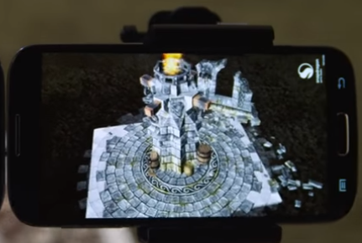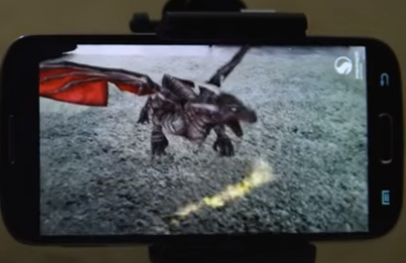

Figure 2‑1 Animation and virtual objects in AR app

Augmented reality can be classified by the methods of display, which are **head-worn**, **handheld** and **projective** (Azuma, R., Baillot, Y., Behringer, R., Feiner, S., Julier, S., & MacIntyre, B., 2001). These three methods involve different interactions. Head-worn displays (HWD) require users to mount it on their heads and provide virtual imagery in front of their eyes. The second method, handheld displays use an attached camera to act as a window in providing augmentations that shows the real environment with AR overlay influence. The third method, projection displays project the desired virtual image directly on a physical object, and thus it becomes augmented. Among these three methods, handheld display is the most common method in the mobile devices market.

## Recent Measuring Systems

### The programmable Optical 3D Measuring System POM – Applications and Performance

This system is a programmable 3D multi-sensor measuring system for non-contact optical measurements of points and elements by applying digital image processing and close-range photogrammetry techniques (Loser, R., Luhmann, T., & PMU, L. H., 1993). It is initially developed for measuring large components in the automobile industry. The system can measure an object made from different materials in 3D spaces, as the system enables detection of the object, then setting up some points on the object edges. Each of the geometric elements, such as a circle, sphere, line and cylinder involve in different measurements and image processing algorithms. The measurements can be performed in either manual or automatic mode.

Figure 2‑2 shows the overall software structure of the POM system. At the beginning, the users will enter a graphical user-interface to control and insert the commands needed to measure the elements. For the central control unit, program interpreter will check the correct syntax and executes the commands given. In program interpreter, there are tons of processes implemented, including the process control, sensor groups and image processing. The data executed will run through the calculation programs and algorithms, and finally shows the result.

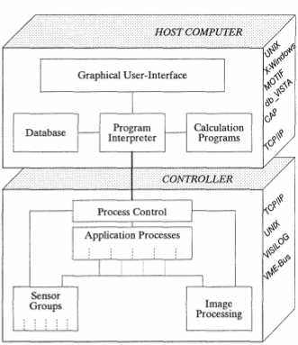

Figure 2‑2 Software structure of POM (Loser, R., Luhmann, T., & PMU, L. H., 1993)

The system requires to work with various suitable imaging sensors and cameras, such as Pollei Reseai-Scanning Camera (RSC), CCD video cameras and digital rotary table. Besides, it also needs a light source for defining and positioning the object to measure the size.

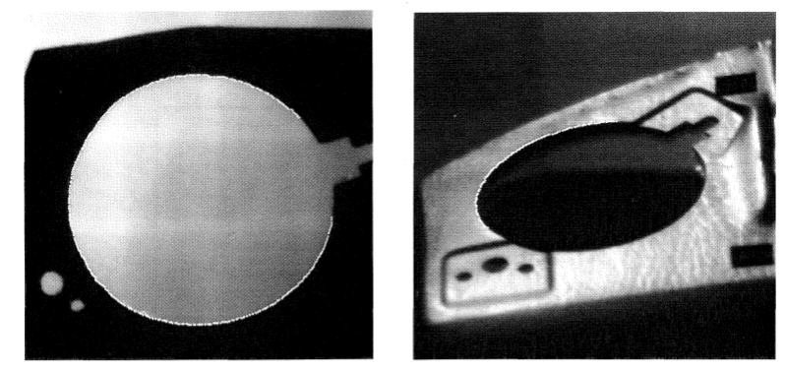

Figure 2‑3 Sample element to measure in POM (a circular loudspeaker hole)

The white dots beyond the edges of the circular loudspeaker hole represent the points detected by the sensors, this allows the system to continue its measurement with accurate data. The left figure was taken from the bottom, and the right figure was taken from the top.

After the measurement and calculation have been done, all data including observation processes, sensors data and results will be stored in a network database. The data stored will be arranged according to the measured elements, which allows user to track back the previous result easily.

### 3D Measuring of Complex Automotive Parts Using Video-Laser Scanning

In this research, the researchers aim to discuss the applications and the advantages of measuring 3D complex objects by using the techniques of 3D scanning, especially video-laser scanning (Voicu, A., Gheorghe, G. I., & Badita, L., 2013). It mentioned that 3D scanning is a process that uses a contact or non-contact digitizing detector to scan and capture an object form and recreate it into a virtual environment as a 3D graph presentation. The graph will be saved as various CAD formats, and the data will be modeled by using algorithms with the support of the sensors and detectors.

Nevertheless, 3D video-laser scanning has a great advantage among other measuring methods, which is fast and efficient. As 3D measuring systems are able to measure all necessary parameters without errors, it may stand as an important development for some specific industries, such as biomedical and architecture industries. An accurate and low tolerance result is very important to a doctor who needs to know the volume and sizes of organs, or an architect who wants to know the length and width of the materials.

### PC-Based 3D Image Measuring Station with Digital Camera: an Example of Its Actual Application on a Historical Ruin

This system is a PC-based photogrammetry system, that can be used to accomplish plotting and original image creation in real time (Kochi, N., Ito, T., Noma, T., Otani, H., Nishimura, S., & Ito, J. , 2003). It aims to be convenient and reduce time needed to calculate either a building or a historical ruin, whereby the experts may proceed to next step faster. The system can identify the images provided and measure the images, transform it into a 3D display with detailed information. It has developed using few simple tools: a digital camera and a laptop computer.

The way of using this software is taking pictures by a digital camera on a fixed spot, which camera-parameter has already installed in the computer. The numbers of image taken in different calibrated zooms will affect the accuracy of the elements. The pictures will be imported to the laptop computer and visualized in a 3 dimensions graph. Finally, the system will execute the detailed measurement and plotting of the 3D graph to get the outputs, and the results will be implemented in the final plan.

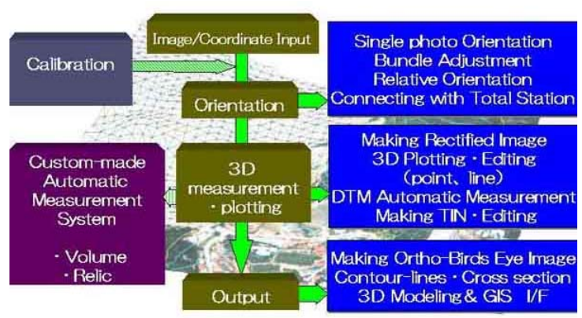

Figure 2‑4 The system structure of 3D Image measuring Station (Kochi, N., Ito, T., Noma, T., Otani, H., Nishimura, S., & Ito, J. , 2003)

The system is able to achieve and collect a positive and satisfactory result using measuring techniques, which the accuracy is around ±1 pixel = ±1cm. Besides, the 3D modelling of the elements can be finished in less than 10 minutes and the measurement will only take a few seconds.

## Similar Works

### On 3D-Camera Measure

On 3D-Camera Measure is an AR measuring app on Android that performs a non-contact measurement. It can measure an object’s size in any direction and plane in 3D space. The requirements for using this app is placing a small rectangle object on the object measured. It has various features for users to measure, which are length, angle, area and diameter. It can measure a round object as well.

To measure the required object, the user should take a full-size photo with the small object place on it. The small rectangle object placed on the plane is to adjust the AR’s ground plane by dragging the points to the exact spots. The small circle at the right bottom is for micro-adjusting of both small object and the target object.

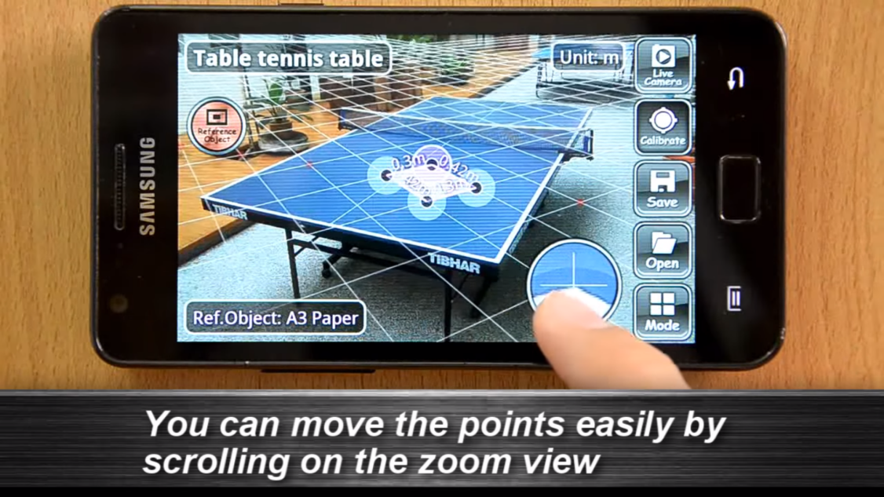

Figure 2‑5 Adjustment of ON 3D-Camera Measure

After finished the adjustment, the ground plane is ready to be used to measure the area of the tennis table. Figure 2‑6 is the result of the measurement. The unit of the result can be changed to centimetre, inches and feet.

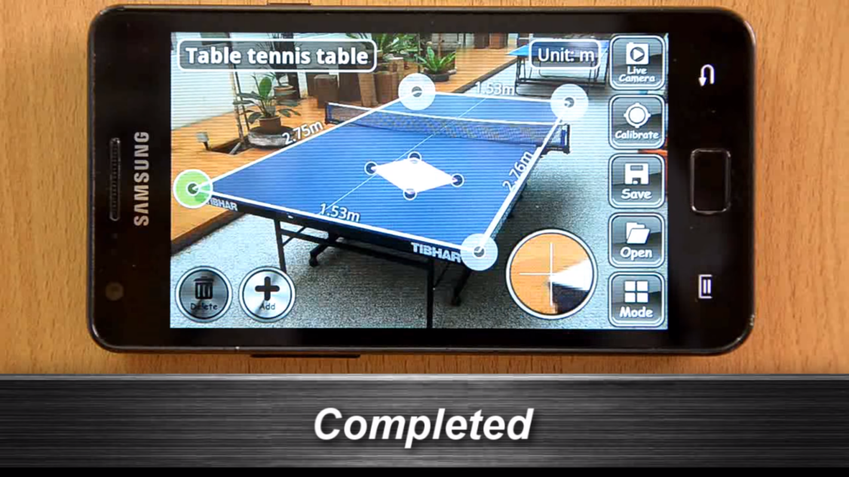

Figure 2‑6 Output of the measurement

### AirMeasure

AirMeasure is a measuring app released on iOS and Android (beta version). It performs non-contact measurement by providing a pointer and button to user in the app. No object is required in AirMeasure, the app is able to identify the distance between mobile device and the target object to measure the length of the target including complex object, such as sofa. There is a feature called Surface mode, which the ground plane shown in the app will appear automatically after the application finished detecting the surface of the object.

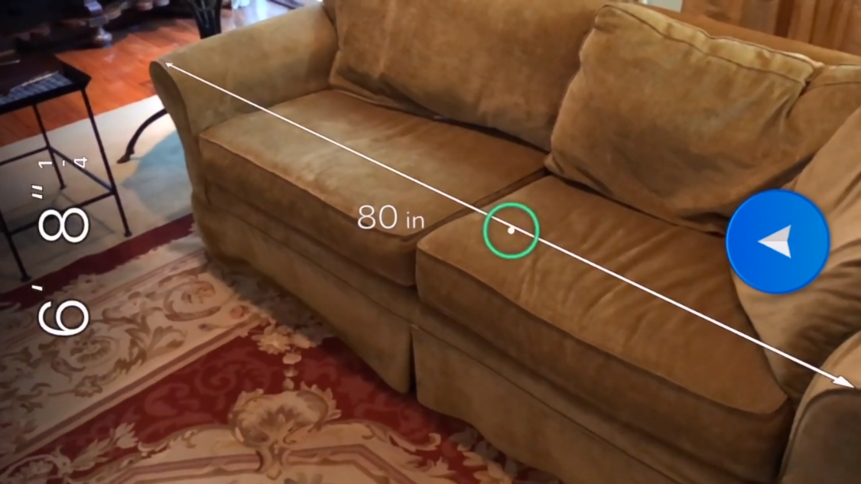

Figure 2‑7 Normal measurement of AirMeasure

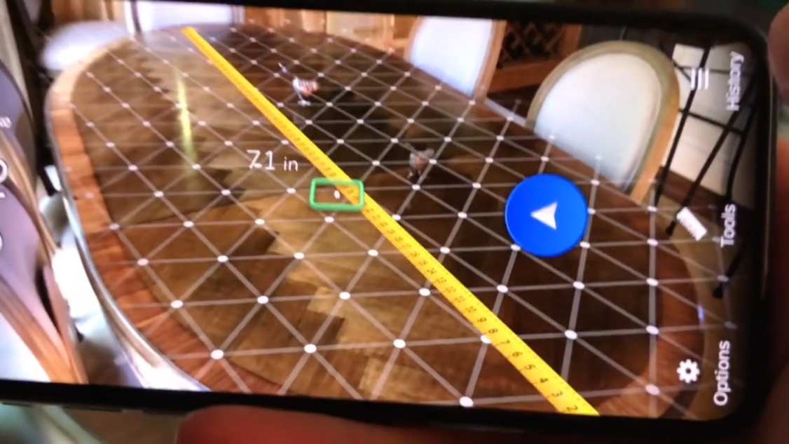

Figure 2‑8 Surface Mode feature

Although the normal function of AirMeasure is measuring the length of the object, it does provide the Floorplans feature, which the user can measure the area of the housing surface. Circular surface and area are the exception for the app as it can only measure the area which has exact angles.

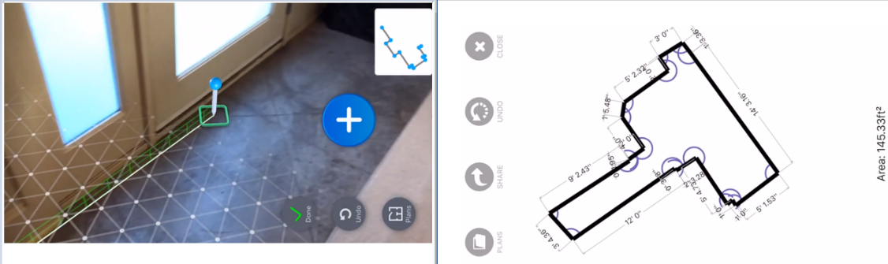

Figure 2‑9 Floorplans feature and its’ output

### Measure

Measure is a measuring app released by Google in September of 2016 for project Tango devices. It can measure an object’s length and area by dragging the point to adjust the angles or spots of the object. A ground plane will be shown in anytime for measuring an object or the floor surface. It also provides unit switch features and precision display features. It shows the possible error of the measurement as well. In Figure 2‑10, the measurement is shown and the possible error shown by system is ±1inch.

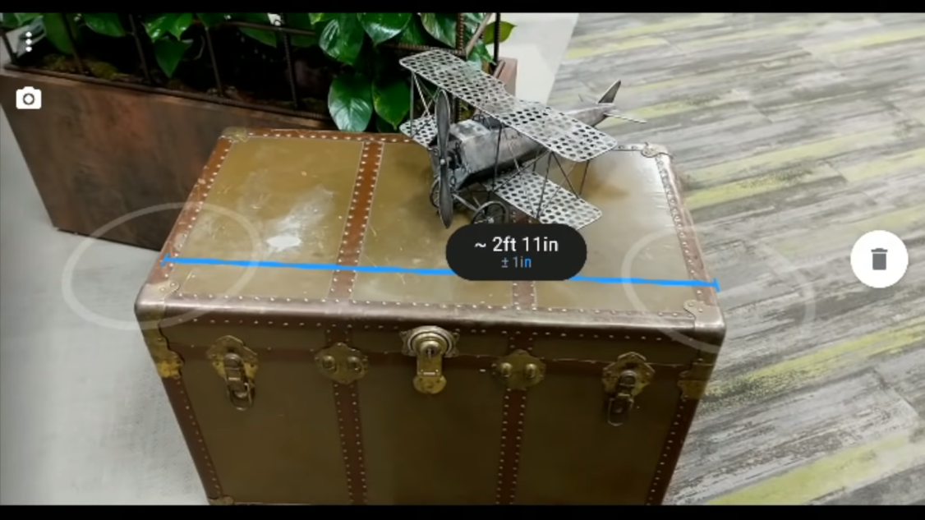

Figure 2‑10 Result and possible error on Measure app

## Comparison on Similar Works

The table below shows the overall differences between three similar works reviewed.

|  |  |  |  |  |
| --- | --- | --- | --- | --- |
| System  Feature | ON 3D-Camera Measure | AirMeasure | Measure | Planned System |
| Object required for measuring | ✔ |  |  | ✔ |
| Circular measurement | ✔ |  |  |  |
| Unit Switch | ✔ | ✔ | ✔ | ✔ |
| Photo/ real-time video | Photo | Real-time video | Real-time video | Real-time video |
| Platforms | Own libraries | ARCore | ARCore | Vuforia |

Table 2‑1 Comparison on similar works

From Table 2‑1 given, we can see that ON 3D-Camera Measure is considered as the most convenient and portability measuring app due to the reason that ARCore only allows its supported devices to be used for the app because of the ARCore’s API level. However, ON 3D-Camera Measure does not considered as an AR app as it does not fulfil the requirement of being an AR system, which is real-time localization tracking.

## Overview of Implemented Techniques and Software

### Unity

About Unity Game Engine, it is integrated by a custom rendering engine with the nVidia PhysX physics engine and an open source implementation of Microsoft’s.Net libraries, called Mono (Craighead, J., Burke, J., & Murphy, R., 2008). It has four major characteristics that makes Unity Game Engine a great development platform, which is **completed documentation** with examples for its API, **active online developer community** which experienced developer may provide assistance to new users, an **easier development environment** in a drag-and-drop manner, and **multiplatform distribution**. Compared to Unreal, Source and Torque, Unity has a better experience and lower cost to development, and thus Unity will be used for further exploitation.

#### Comparison of Unity and Unreal Engines

The comparison of Unity and Unreal engines is a debatable topic in this industry. Although both Unity and Unreal engines are having some similarities at some extent, their pros and cons will be discussed in this section.

Unity is having a competitive edge in regard to its larger development community as people are able to find the solutions or resources more easily whenever they are having trouble. Considering customer’s experience, Unity is more intuitive to be used and better quality of demos are produced to provide incentives for people in learning more about it. On the other hand, Unity is having a longer existence compared to Unreal which means the system is more familiar for people in this industry and better technical support can be found. However, as some of the features that required for some sort of contents are not free and need to purchase from the asset store.

For Unreal, it is superior in terms of providing the higher quality of image using their graphics production techniques. It offers larger contents of free add-ons which is winning out in this part compared to Unity. However, due to the use of different programmer language, C++, it is relatively more complicated for programmer and not user friendly. The lack of documentation is one of the drawbacks that influenced the quality of the software as the effectiveness and efficiency of using this engine will be affected due to the lack of up-to-date guidelines and information.

In conclusion, Unity has a better user community and longer existence compare to Unreal Engine. Besides, Unity has a better technical support which the user is able to get their development done easily, while the benefit of Unreal Engine is only provides higher quality of the images, which is not very necessary for AR. Therefore, Unity becomes the platform for developing the app.

### Vuforia SDK

Vuforia is an AR SDK for smart mobile devices to execute AR applications into a real time video obtained from the devices (Ibañez, A. S., & Figueras, J. P., 2013). It supports both native development for iOS and Android, while also acts as an extension of Unity Engine as that is easily portable to both iOS and Android platforms. The developers may upload the input images or resources for the target that he wants to track, and then access it either through cloud link or directly from the application’s local storage (Amin, D. & Govilkar, S., 2015). This is due to the traceable features and binary files that contain traceable database are compiled into the app installer package and can be used at run-time.

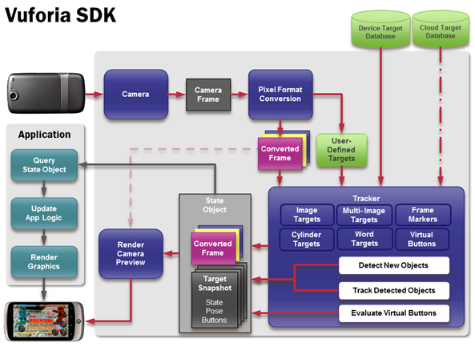

Figure 2‑11 Vuforia SDK architecture (Akanksha, 2014)

Vuforia SDK supports both 2D and 3D targets, it enables user to place AR content on a 2D image, simple 3D shape such as cube, cylinder or even conical.

#### Comparison of Vuforia and other AR SDK

|  |  |  |  |
| --- | --- | --- | --- |
| SDKs  Feature | Vuforia | ARCore | ARKit |
| Platform | iOS and Android | iOS and Android | iOS |
| Device specifications | Suitable for most phone device | Android 7.0 and iOS 11.0,  specified phone device | iOS 11.0,  iPhone 6s and newer |
| Main way of imposing virtual object | Image based | Ground plane detection | Ground plane detection |
| Cost | Free version with Vuforia watermark  (Development license provided) | Free | Free |

Table 2‑2 Comparison of AR SDKs

After exploring and researching which AR SDKs is going to be used, ARCore is the one outstanding compared to others. However, it only supports the phone devices that are listed at its official site. Most of them are released since 2017, which are newer, and higher hardware specs. Besides, the accuracy of measuring an item is always complained by users since Google publishes their measuring app due to its anchoring issues when users orient the screen. Although Vuforia is in marker-based, it will generate a great result with the calculations implemented. Therefore, Vuforia is decided to be used as the tool in this project.

# Requirements and Theoretical Framework

## Use Case Diagram

A use case diagram is a graph representation of the elements interact in a system. It is used to identify, clarify and organize the requirements of a system needed. A use case diagram contains 4 components, which are the boundaries, actors, use cases and relationships. The boundary defines the system of interest. The actor represents an individual involves with the system according to their roles. The use cases are the modules which will be used by the actors in the system. The relationships are the links among actors and use cases.

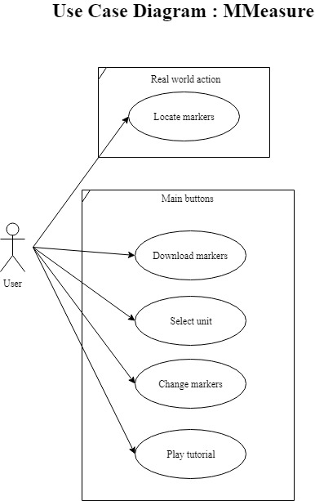

Figure 3‑1 Use case diagram

The use case diagram represents a summary of the measuring app. As a marker based AR application, the system will have detection on the markers, but the user needs to locate its’ position manually. The user plays as a role of downloading the markers, which a link is provided to perform the action. The markers will have two sets of the sizes, depends on the range of the distances from camera. The system will calculate the length between two markers with default of centimetre. Therefore, a function of changing unit will be provided for users, and the choices are in centimetre, meter, inch and foot. A tutorial is given as well; in case the user has misunderstanding of confusion when using the app.

## Context Diagram

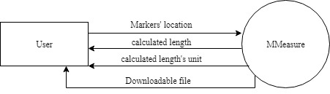

Figure 3‑2 Context diagram

The context diagram represents a general requirement of the measuring app provides. However, the arrows only show the data flows of the whole system, while some functions do not relate with data (swapping scene or clicking buttons), therefore they are not included in this diagram.

## Software and Hardware Requirements Specification to Develop Proposed System

### Hardware Requirements

Recommended specifications:

* 2.4GHz Intel Core i7 processor (Max Turbo frequency 3.4)
* 8GB RAM
* Up to Hybrid 24GB Nand,1TB 5400rpm storage
* NVIDIA GeForce GT740M graphics

### Software Requirements

* Unity
  + Android Build Support
* Vuforia SDK (as Unity extension)
* Android Studio (an environment variable for developing Android app)
* Visual Studio 2017
* Heroku CLI
* GIT
* Composer

### Software Language Used

* C#
* PHP
* HTML

## Software and Hardware Requirement to Run Proposed System

### Hardware Requirements

* An Android device
* Android 4.1 APIs (Jelly beans)

# Design and Research Methodology

## Proposed Methodology

In every application-based project, a software development model shall be determined and implemented to have a better and more efficient development. A software development model is a methodology that used to develop the project depending on its scope and purposes. It also enhances the development experiences and provides a more comfortable development process for developers. Each development model has its characteristics to achieve to project’s requirements and objectives in a more convenient way.

### Prototyping Model

In this report, the prototyping model will be the development model of the project. The prototyping model is a system development method that a prototype is built and tested based on the project scopes. The prototype will be reworked again and again until an acceptable prototype is finally achieving the actual requirements which the complete system can start to be developed (Rouse, 2005).

Prototyping model has been chosen for this project due to the high contact of user experience. The user’s feedback is highly emphasized to provide better performance and satisfaction. Besides, the requirements need to be changed more often based on the user requirements. Therefore, prototyping model will be a better solution.

The advantages of using prototyping model are:

* Highly involved users and testers during development
* Earlier errors detection
* Obtaining user feedback for solving system errors
* Shorter development process
* Easier user comprehension of the system

## Structure Design

### Flowchart Diagram

In this section, the structure and design of the app is explained using flowchart diagram, which will provide a better understanding of how the measuring app works. First of all, the main flow of the app is shown as Figure 4‑1, as the app will not exit unless the user hits “Exit” button. When running the app, the user may perform any function, which shown as Figure 4‑2.

#### Main Flow

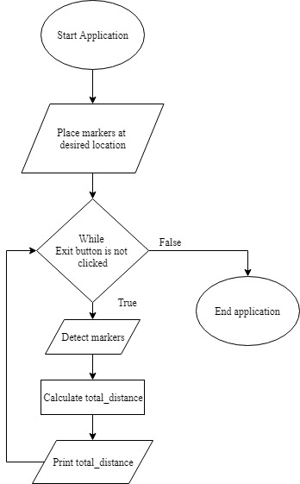

Figure 4‑1 MMeasure main flow

#### Main Functions

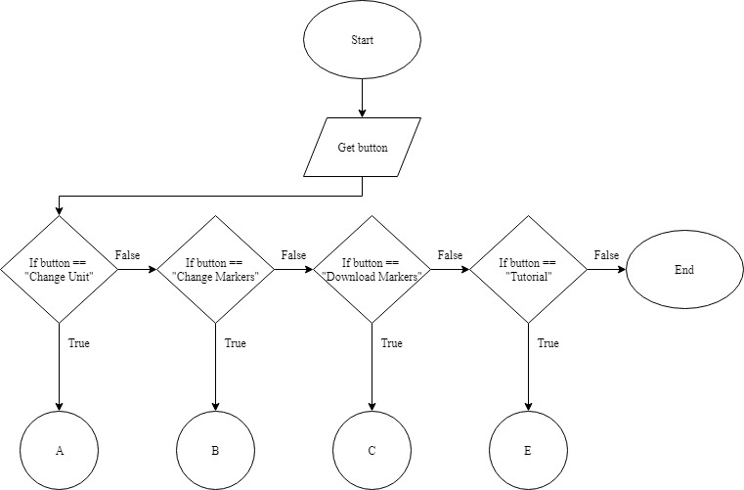

Figure 4‑2 MMeasure's main buttons and functions

#### Changing Unit Function

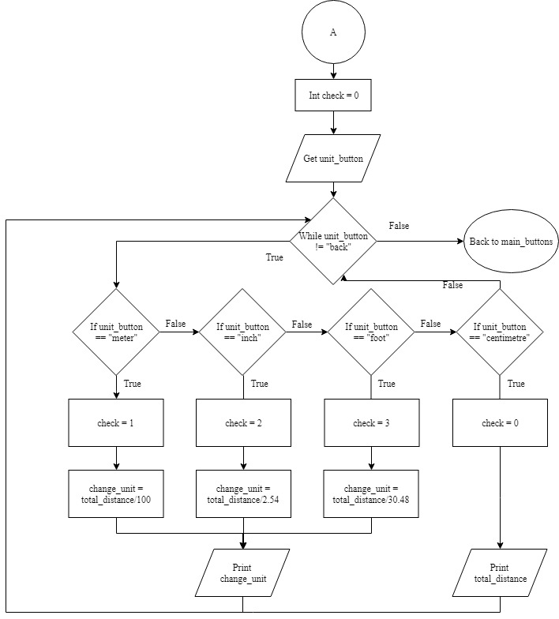

Figure 4‑3 Changing unit function

By clicking “Change Unit” button, four options will be given to user, which are “meter”, “inch”, “foot”, and “centimetre”. Choose any option will execute the calculations, and the trigger “check” will be changed to current unit. Hit “back” button will hide the unit_buttons, and shows main_buttons.

#### Change Markers Function

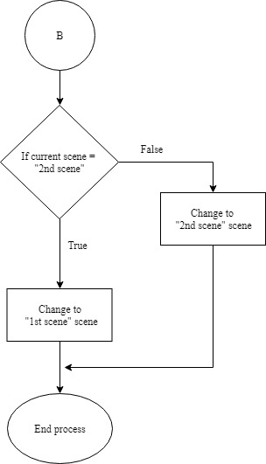

Figure 4‑4 Change markers function

There are three scenes in total inside the measuring app, which are “1st scene”, “2nd scene”, and “HowToUse”. “1st scene” and “2nd scene” are used for two different sets of markers to handle different range of distance away from camera, while “HowToUse” scene is created for showing the tutorial. Only “1st scene” and “2nd scene” are involved in this function to perform change markers function by clicking “Change Markers” button.

#### Download Markers Function

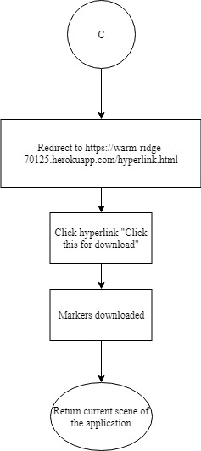

Figure 4‑5 Download markers function

By clicking “Download Markers” button, the app will redirect user to link: <https://warm-ridge-70125.herokuapp.com/hyperlink.html>, which a hyperlink is provided. Click the hyperlink and the user may download the markers needed.

#### Tutorial

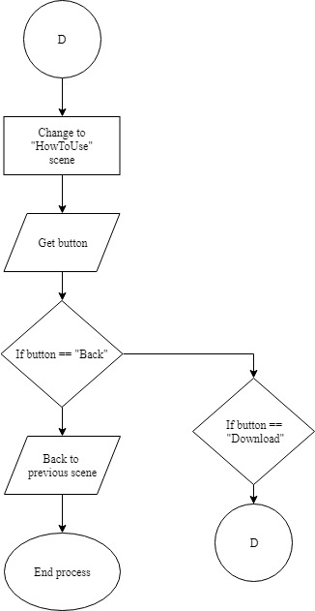

Figure 4‑6 Tutorial

After clicking “Tutorial” button, the scene will redirect to “HowToUse” scene. There are two buttons provided, which are “Back” button and “Download” button. Click “Back” button will redirect user to the previous scene, which are either “1st scene” or “2nd scene”. Hit “Download” button will have the steps of Figure 4‑5 given above.

### Sequence Diagram

#### Locate Markers

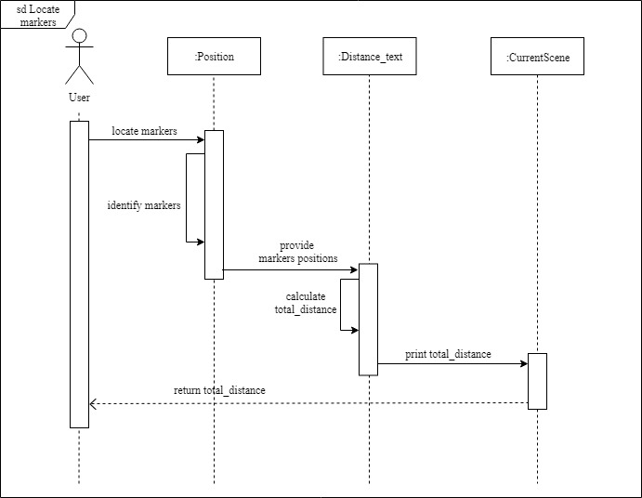

Figure 4‑7 Locate markers sequence diagram

### Change Markers

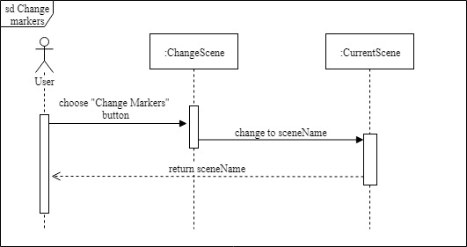

Figure 4‑8 Change markers seuqence diagram

#### Select Unit

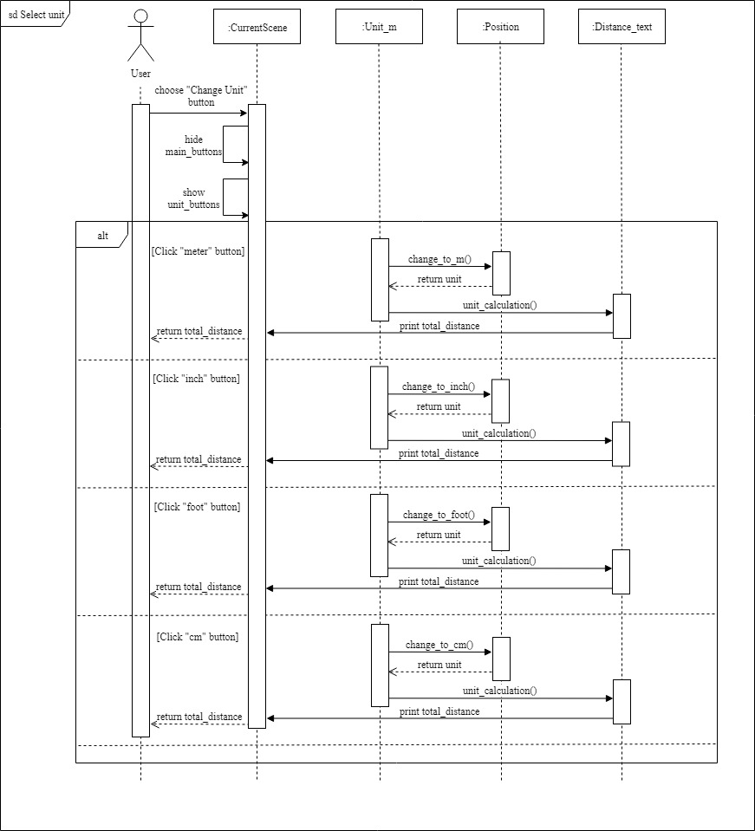

Figure 4‑9 Select unit sequence diagram

#### Download Markers

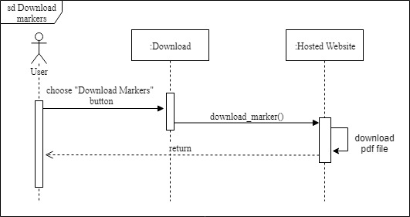

Figure 4‑10 Download markers sequence diagram

#### Play Tutorial

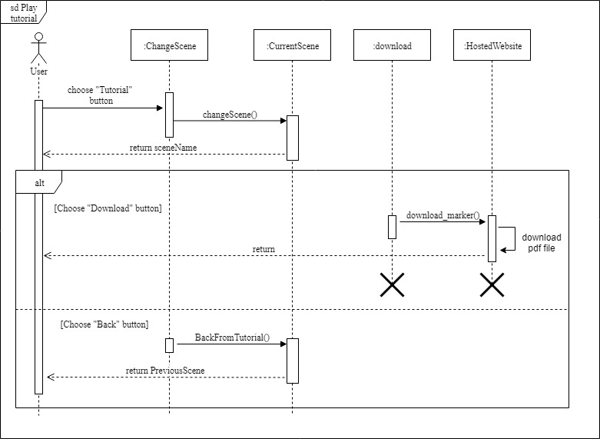

Figure 4‑11 Play tutorial sequence diagram

*Note: Please refer to appendix C: Source Code for more understanding of the attributes, class and methods.

## Application Design

### Image Target Design

Since the Vuforia SDK is highly relied on the markers (image target), its design will influence the output with a critical rate. First of all, the size of the marker must be exactly the same with the one in real world due to the implementation of the tracker itself. The tracker needs to get information from real world, such as the distance from camera, the identifications marked on the markers, and the position of the markers. The information will be returned to the tracker when tracking in same scale.

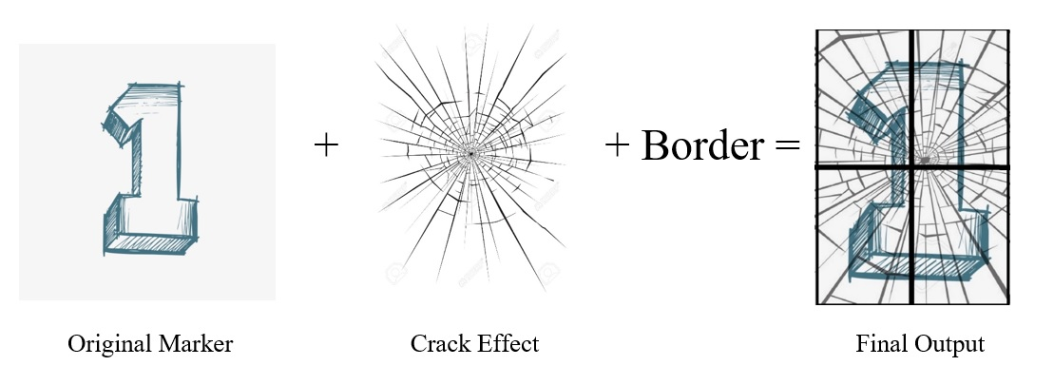

Figure 4‑12 Materials of creating a marker

Apart from that, four markers are layered with four different effects. This action will help to increase the contrast of the markers and become easier to tracked by tracker. According to Vuforia Developer Portal, an ideal marker should have three attributes, which are:

1. Rich in details
2. Good contrast
3. No repetitive patterns

With all attributes included, the image target will contain more natural features for Vuforia SDK to be detected and tracked easily. Figure 4‑13 shows the features of a marker, which the yellow crosses are the features initialized by Vuforia Target Manager.

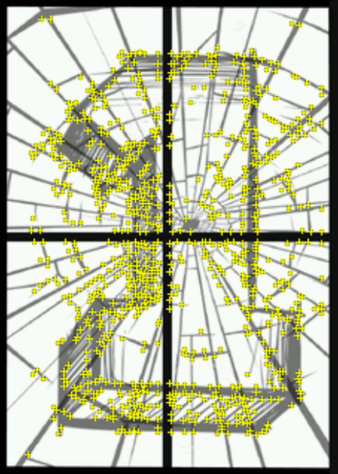

Figure 4‑13 Natural features of a marker

There are four markers in total, and these markers are divided into two sets for handling different distances away from the camera. Marker 1 and marker 2 are handling a maximum distance of 2 meters, while marker 3 and marker 4 handle a maximum distance of 15 meters. However, the markers shall be visible for camera, or the tracker will not able to track them.

Due to copyright issue, the markers are re-designed. The markers are bundled into a PDF file named image_for_print. Inside the PDF file, some instructions are written for user to follow. The full PDF file is attached and can be referred in Appendix.

### GUI Design

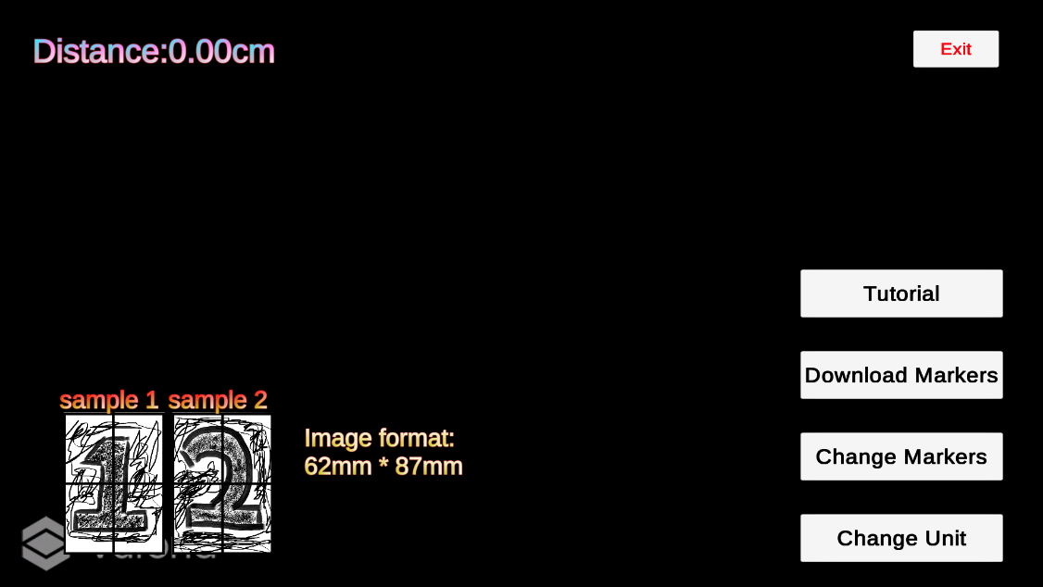

Figure 4‑14 Interface of 2nd scene

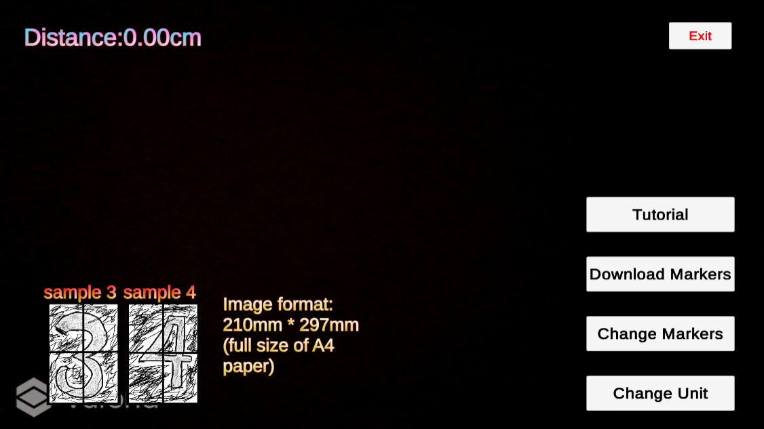

Figure 4‑15 Interface of 1st scene

Figure 4‑14 and Figure 4‑15 shows the overall design of the application. A length, which is the final result is showed initially at top-left side. The samples are provided at bottom-left side as a reference for user to understand which markers they need to use. The markers sizes are provided beside the samples. At bottom-right side, the four buttons: “Tutorial”, “Download Markers”, “Change Markers”, and “Change Unit” are named as a group called main_buttons. An exit button is provided at top-right side.

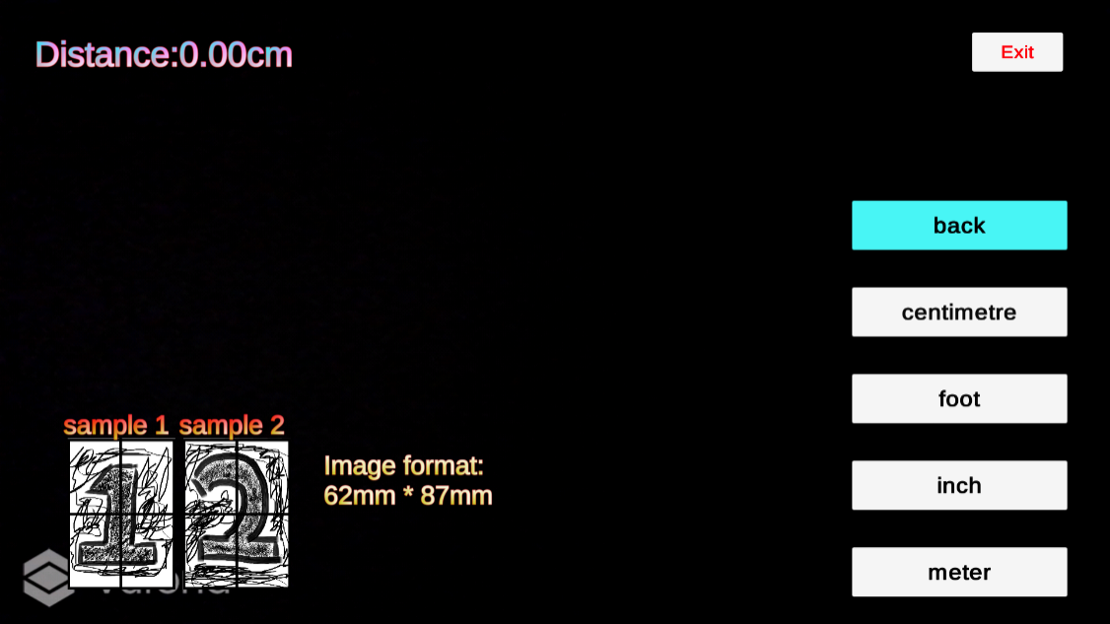

Figure 4‑16 Interface after hitting "Change Unit" button

After clicking “Change Unit” button, the main_buttons will be hided (setActive(false)), and shows unit_buttons, formed by five buttons: “meter”, “inch”, “foot”, “cm”, and “back” button. If the user wants to shows the interface as Figure 4‑14 or Figure 4‑15, hits “back” button is the way.

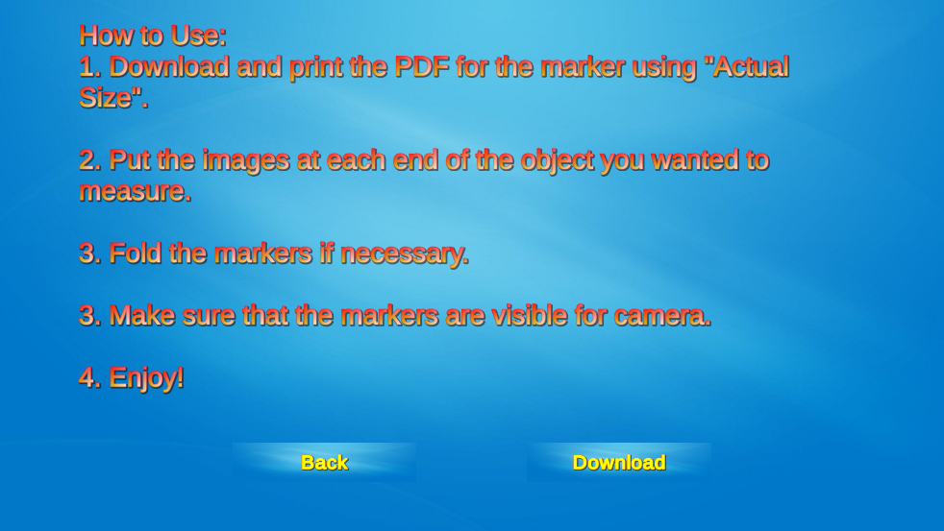

Figure 4‑17 Interface of HowToUse (scene)

The application will redirect user to HowToUse scene after “Tutorial” button is clicked.

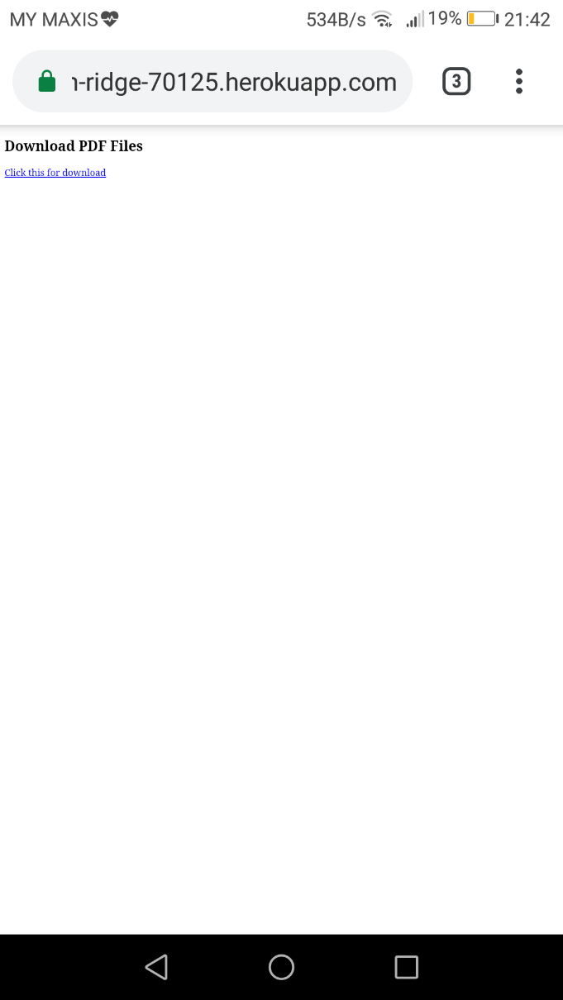

Figure 4‑18 Interface of hyperlink.html

The application will redirect user to hyperlink.html after “Download Markers” button is clicked. The hyperlink will then help user to download the markers in pdf file format.

# Implementation and Solution

## Deploying Markers

### Vuforia License Manager

Before developing the app, a development key must be created by using Vuforia License Manager in order to use the tools and information needed. Each license key created can only be used in a single app. Once a license key is created, the developer is able to assign the image as a marker using Vuforia Target Manager.

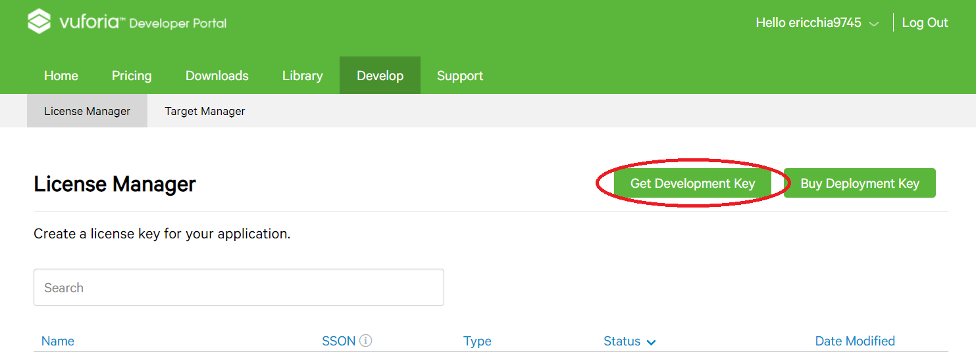

Figure 5‑1 Creating a development key

By clicking the “Get Development Key”, the developer is required to enter the license name. After entering the license name and click “Confirm” button, a license key will be created named as the input entered before.

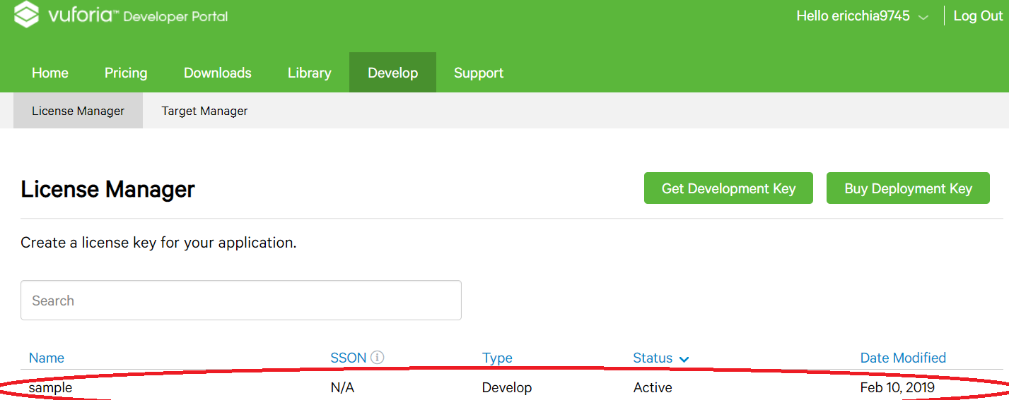

Figure 5‑2 Created license key

The license key is showed after clicking the created license key. The developer is required to copy the generated license key to Unity.

### Vuforia Target Manager

The Vuforia Target Manager is a web-based tool that enables developer to create and manage image based targets as markers online. A database will be created, and the developer may download it as the whole package of targets. Vuforia Target Manager supports both image based targets and VuMarks (a customized Vuforia Engine target), but it does not support all image based targets. The developer must create the targets with the following standard.

1. 8 or 24 bit PNG or JPG files
2. JPG files with RGB or greyscale
3. Maximum file size of 2.25MB

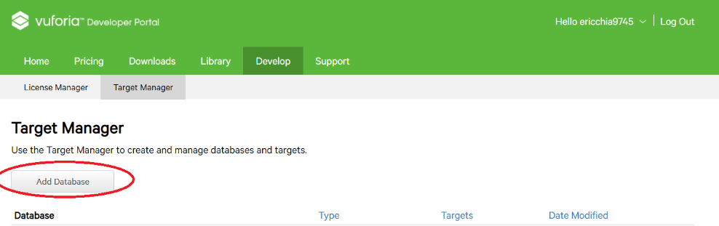

Figure 5‑3 Creating a database

After clicking the “Add Database” button, the developer is required to enter the database name as well.

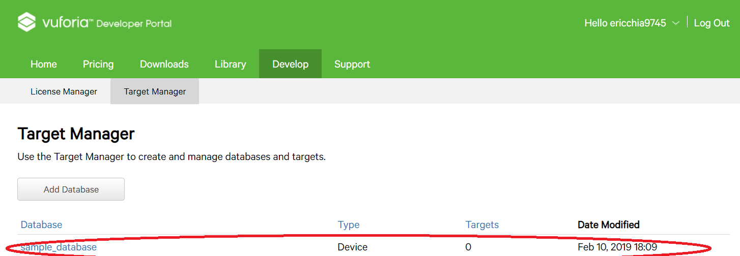

Figure 5‑4 Created database

As the database is created, click it and the developer may use it to create and manage the targets. Figure 5‑5 shows the information needed to create a target.

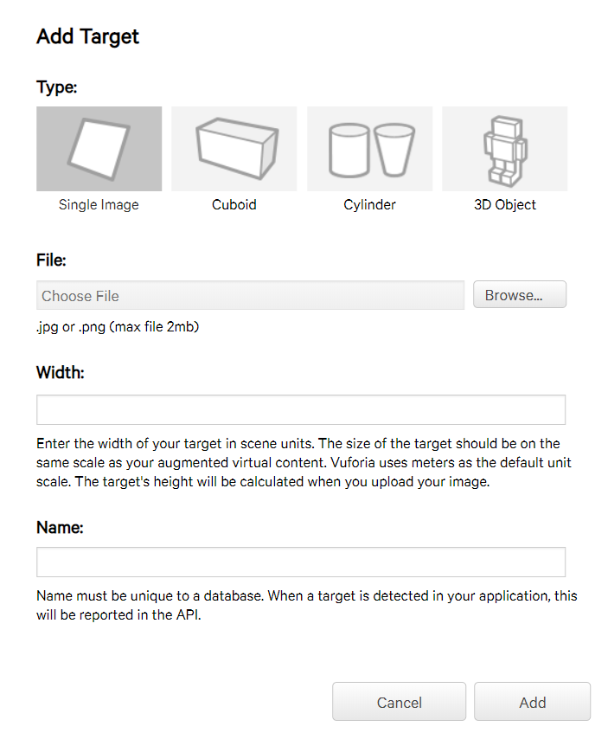

Figure 5‑5 Target setup

## GameObject Types and Descriptions

The types and descriptions of each GameObject is shown as Table 5‑1.

|  |  |  |
| --- | --- | --- |
| **GameObject** | **Type** | **Description** |
| 1st scene/ 2nd scene | | |
| **number 1/ number 3** | **Vuforia-Image** | Marker 1 |
| **number 2/ number 4** | **Vuforia-Image** | Marker 2 |
| **Canvas** | **UI-Canvas** | Interface |
| distance | UI-TextMeshPro | Text of showing the measured length |
| sample image 1/ sample image 3 | UI-Image | Sample marker 1 for user to identify |
| sample text 1/ sample text 3 | UI-TextMeshPro | Sample marker 1 text |
| sample image 2/ sample image 4 | UI-Image | Sample marker 2 for user to identify |
| sample text 2/ sample text 4 | UI-TextMeshPro | Sample marker 2 text |
| Image size warning | UI-TextMeshPro | Marker size format in text form |
| main_buttons | EmptyGameObject | GameObject grouped by the following four buttons |
| *Change Unit* | *UI-button* | Button of casting change unit function |
| *Change Markers* | *UI-button* | Button of casting change markers function |
| *Download* | *UI-button* | Button of casting download markers function |
| *Tutorial* | *UI-button* | Button of casting play tutorial function |
| unit_buttons | EmptyGameObject | GameObject grouped by the following five buttons |
| *change unit_m* | *UI-button* | Button of changing unit to meter |
| *change unit_inch* | *UI-button* | Button of changing unit to inch |
| *change unit_foot* | *UI-button* | Button of changing unit to foot |
| *change unit_cm* | *UI-button* | Button of changing unit to centimetre |
| *unit back button* | *UI-button* | Button of showing main_buttons |
| *exit button* | *UI-button* | Button of exiting the app |
| **Hyperlink** | **EmptyGameObject** | **For attaching script Download** |
| **distance_text** | **EmptyGameObject** | **For attaching script Distance_text** |
| **ExitScript** | **EmptyGameObject** | **For attaching script Exit** |
| **position_parent** | **EmptyGameObject** | **For attaching script Position** |
| **drawnLine** | **EmptyGameObject** | **For attaching script Line_dis** |
| HowToUse | | |
| **Canvas** | **UI-Canvas** | Interface |
| Panel | UI-Panel | Background Image |
| Tutorial text | UI-TextMeshPro | Text of showing tutorial |
| Back | UI-button | Button of redirecting user to previous scene |
| Download sample | UI-button | Button of casting download markers function |

Table 5‑1 Types and descriptions of GameObject

*\*Note: Each button text is using TextMeshPro type.*

## Scripts Attached in Unity

In Unity, a script is usually attached to a GameObject and implemented to other GameObjects. In Figure 5‑6 and Figure 5‑7, the highlighted GameObjects are attaching one script each, and the attached scripts will be shown as Table 5‑2.Table 5‑3 shows the GameObject or scripts attached to attributes in each script, and Table 5‑4 and Table 5‑5 shows the method used in each button.

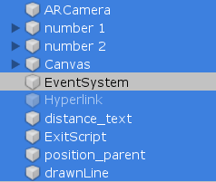

Figure 5‑6 Highlighted GameObjects in Unity (1st scene and 2nd scene)

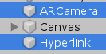

Figure 5‑7 Highlighted GameObjects in Unity (HotToUse)

|  |  |
| --- | --- |
| GameObject | script attached |
| **2nd scene/ 1st scene** | |
| AR Camera | ChangeScene |
| number 1/ number 3 | ImageTrackableBehaviour |
| number 2/ number 4 | ImageTrackableBehaviour |
| Canvas | Unit_m |
| Hyperlink | Download |
| distance_text | Distance_text |
| ExitScript | Exit |
| position_parent | Position |
| drawnLine | Line_dis |
| **HowToUse** | |
| ARCamera | ChangeScene |
| Hyperlink | Download |

Table 5‑2 Scripts attached to each GameObject

### GameObjects/ Scripts Attached to Attributes in Each Script

|  |  |
| --- | --- |
| Attributes | Attached script/ GameObject |
| **Position** | |
| Object 1 | Cube |
| Object 2 | Sphere |
| Pos_x | position1_x (TextMeshProUGUI) |
| Pos_y | position1_y (TextMeshProUGUI) |
| Pos_z | position1_z (TextMeshProUGUI) |
| Pos2_x | position2_x (TextMeshProUGUI) |
| Pos2_y | position2_y (TextMeshProUGUI) |
| Pos2_z | position2_z (TextMeshProUGUI) |
| **Distance_text** | |
| Change | position_parent (Position) |
| Distance | distance (TextMeshProUGUI) |
| **Line_dis** | |
| Cube | Cube (Transform) |
| Sphere | Sphere (Transform) |
| Trackable_status | number 1/ number 3 (ImageTrackableBehaviour) |
| Trackable_status | number 2/ number 4 (ImageTrackableBehaviour) |
| **Unit_m** | |
| Dis_txt | distance_text (Distance_text) |
| Change | position_parent (Position) |

Table 5‑3 GameObjects/ scripts attached to attributes in each script

### Methods Attached in Each Button (OnClick())

#### 1stscene/ 2nd scene

|  |  |  |
| --- | --- | --- |
| Button | GameObject/script attached | Method used |
| **main_buttons** | | |
| Change Unit | unit_buttons | GameObject.SetActive(true) |
| main_buttons | GameObject.SetActive(false) |
| Change Markers | AR Camera | ChangeScene.changeScene(1st scene) *2nd scene  ChangeScene.changeScene(2nd scene) *1st scene |
| Download | Hyperlink | Download.download_marker |
| Tutorial | AR Camera | ChangeScene.changeScene(HowToUse) |
| **unit_buttons** | | |
| change unit_m | Canvas | Unit_m.change_to_m |
| Change unit_inch | Canvas | Unit_m.change_to_m |
| Change unit_foot | Canvas | Unit_m.change_to_m |
| Change unit_cm | Canvas | Unit_m.change_to_m |
| Back | unit_buttons | GameObject.SetActive(false) |
|  | main_buttons | GameObject.SetActive(true) |
|  |  |  |
| Exit button | ExitScript | Exit.ExitApp |

Table 5‑4 Methods Used in each button (1st scene/ 2nd scene)

#### HowToUse

|  |  |  |
| --- | --- | --- |
| Button | GameObject/script attached | Method used |
| Back | AR Camera | ChangeScene.BackFromTutorial |
| Download sample | Hyperlink | Download.download_marker |

Table 5‑5 Methods used in each button (HowToUse)

## Solution/ Algorithm

### Calculating Length Between 2 Objects

The algorithm is using the method of Pythagorean Theorem, which the concept is as Figure 5‑8.

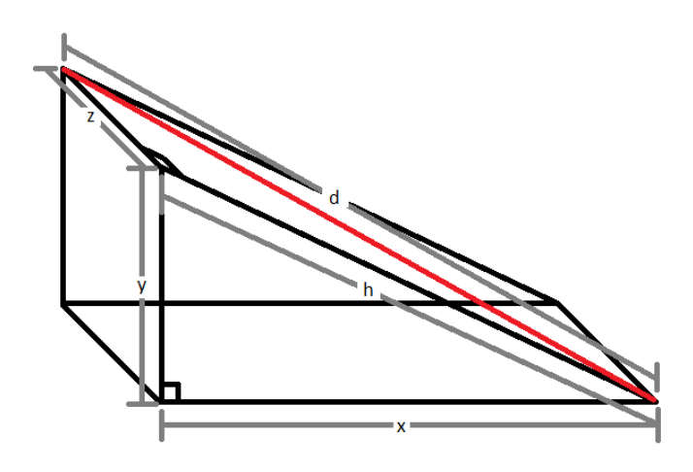

Figure 5‑8 Example of using Pythagorean Theorem to calculate 3D space length

D is the length wanted to be measured, where d² = z² + h², where h² = x² + y². Therefore, the equation will be d = √(x² + y² + z²). x, y, and z are represented as the subtractions of each axis respectively. (Refer to Distance_text source code)

### Length Line

In phase 1, there are 3 lines represented as the lengths between the markers, which are x-axis, y-axis, and z-axis. This concept is abandoned in phase 2 as it does not show the length clearly, and it may cause errors on the alighment of the markers. One LineRenderer called drawnLine is used to replace the old concept.

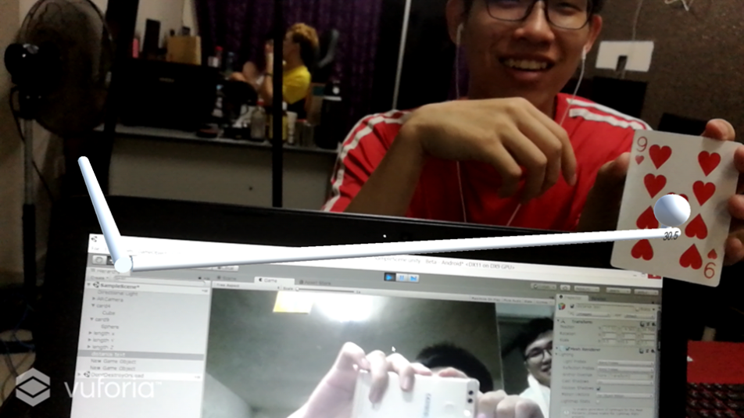

Figure 5‑9 Length lines in phase 1

As mentioned in Table 5‑2, both number 1/ number 3 and number 2/ number 4 are attached with ImageTrackableBehaviour. This script is used to identify whether the markers are being tracked or not. This is important that the result is used inside Line_dis script. If either one marker is not being tracked, the line will not be drawn. The purpose of doing this is to make the interface cleaner and prevent misunderstanding of the calculated length.

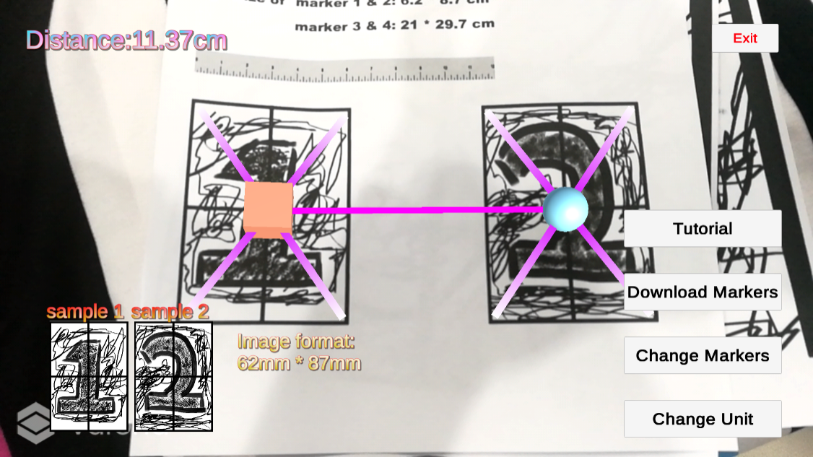

Figure 5‑10 Two markers tracked

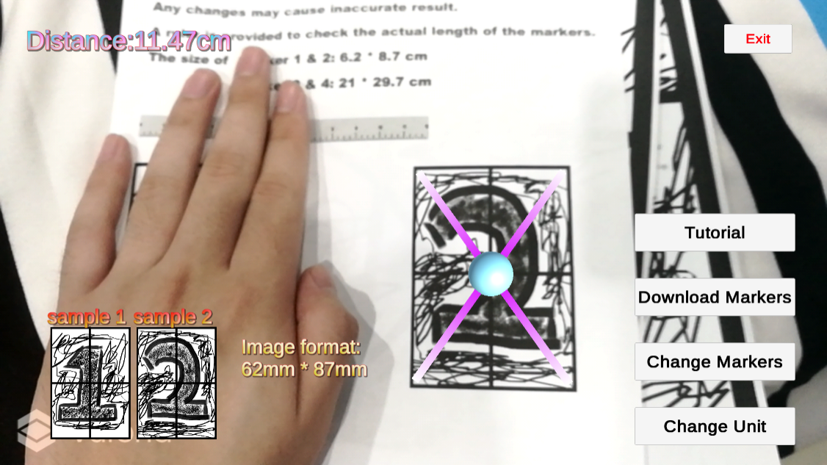

Figure 5‑11 One marker tracked

### Downloadable Markers

Since this is a marker based AR application, the markers are necessary for user. The markers are in a PDF file, which is convenient for user to print. However, the user should print the PDF file in “actual size”, in case of causing inaccurate result due to the marker size.

A host is created using Heroku, it also provides SSL support for the website. SSL support is important in providing link, as the link provide in script must have HTTPS. During the process, a tools called Composer is needed for accessing the host.

# Testing

## Test Plan

### Purpose

A test plan will support the following objectives:

* To detail the activities required to prepare and conduct the system test.
* To define the sources of the information used to prepare the plan
* To define the environment needed to conduct the system test

### Scope

The scope of testing shall only cover black box-functional testing for the features developed in the measuring app, MMeasure. This test plan shall only cover the system level test, excluding unit test, static test, integration test, acceptance test, regression test, confirmation test, and any other tests that did not mention in this Test Plan. The focus of this document is to meet the requirements of the system and making sure the system fits its intended purpose.

### Test Environment

To test the application, a Huawei P9 with Android version 7.0 will be used.

### Feature to be Tested

The following documents will provide the basis for defining correct operation:

* Use Case Diagram: MMeasure (Chp 3.1)

|  |  |  |
| --- | --- | --- |
| **Feature ID** | **Description** | **Risk Level** |
| F001 | Locate markers | High |
| F002 | Change unit | Medium |
| F003 | Download markers | High |
| F004 | Change markers | Medium |
| F005 | Play tutorial | Low |

Table 6‑1 Functionalities to be tested

### Test Priorities

F001 should be tested first and it need to be considered as the highest priority as the error may occur if the application does not locate well. F005 will be the lowest priority of testing as it only plays as a role of guiding user about the steps of using the application.

### Pass/ Fail Criteria

The system must satisfy the following criteria in order to pass:

* All test cases must be passed.
* The system does not crash or go into an unknown state during operation.

### Suspension and Resumption Requirements

* Suspension criteria: If an issue cannot be solved, do not test the specific function as it cannot be tested at all.
* Resumption criteria: If the issue is solved, the test can be conducted.

### Test Result

|  |  |  |
| --- | --- | --- |
| Functionality ID | Expected Result | Actual Results |
| F001 | The markers are able to be tracked, and the virtual objects are imposed well. | As expected. |
| F002 | The unit is able to change to the required ones, and the calculation is well-performed. | As expected. |
| F003 | The app shall redirect user to the expected site, and the PDF file can be downloaded. | As expected. |
| F004 | The scene is able to be changed. | As expected. |
| F005 | The app is able to show HowToUse scene. | As expected. |

Table 6‑2 Test result

## Accuracy

Since accuracy is the focal point of MMeasure, it was tested using different angles and distances away from camera.

The angles are referring as the angles of the rotating the camera. There are three angles to be tested: 0°, 45°, and 90°. The distances away from camera will have three tests as well, which are: 20cm, 30cm, and 50cm.

Each test will have 10 attempts and the app is rebooted in each attempt. It aims to test the stability of the measurement. The tested markers are marker 1 and marker 2, and the tested length is 11.4cm. Each test will be divided by 10 in order to find the average result, and the result is shown as below.

|  |  |  |  |
| --- | --- | --- | --- |
| Degree  Distance | 0° | 45° | 90° |
| 20cm | 11.41cm | 11.44cm | 11.41cm |
| 30cm | 11.39cm | 11.51cm | 11.41cm |
| 50cm | 11.45cm | 11.43cm | 11.40cm |

Table 6‑3 Result of different angles and distances

The result shows that the error is around ±0.1cm, which is good. Different lengths are going to be tested on next testing. The angle is fixed as 0° and the distance away from camera is fixed as 50 cm. Three lengths are provided, which are: 20cm, 30cm, and 50cm. Each test will have 10 attempts as well, and the average result will be shown as the table below.

|  |  |
| --- | --- |
| Actual length | Measured length |
| 20cm | 20.04cm |
| 30cm | 30.01cm |
| 50cm | 49.98cm |

Table 6‑4 Result of measured length

The result shows that the error is around ±0.1cm, but the error may become bigger when the length is longer. A testing by using marker 3 and marker 4, with the 0° angle, 2 meters distance from camera, and the actual length of 180cm may cause error around ±0.4cm. However, the result seems to be more accurate as the error is within ±1cm.

## Usability Testing

In non-functional testing, a google form that contains 7 questions is created to test the usability of the app. 20 people has been responded about their impression of MMeasure. The questions asked are:

* + How easy do you find to use the system?
  + How accurate do you find the measured length is?
  + Do find MMeasure is useful?
  + Do you think the feature of downloading markers is convenient?
  + Do you think the instructions given in Tutorial is understandable?
  + What area do you think the system can be improved?
  + How would you rate the overall app?

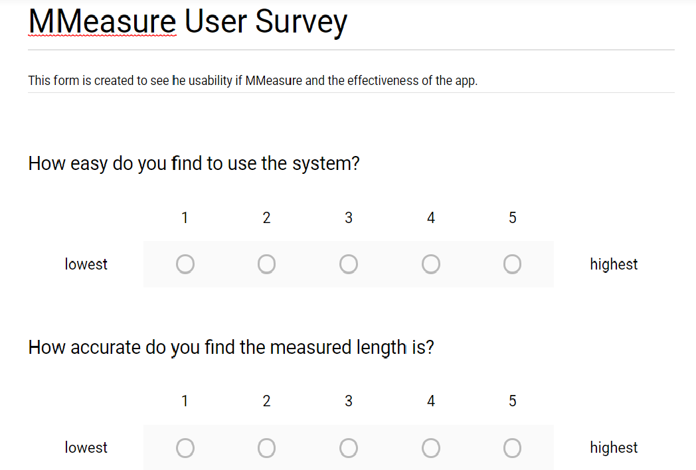

Figure 6‑1 User evaluation form 1

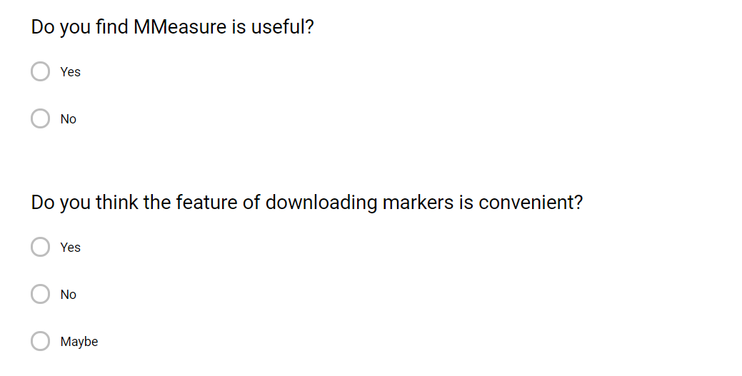

Figure 6‑2 User evaluation form 1

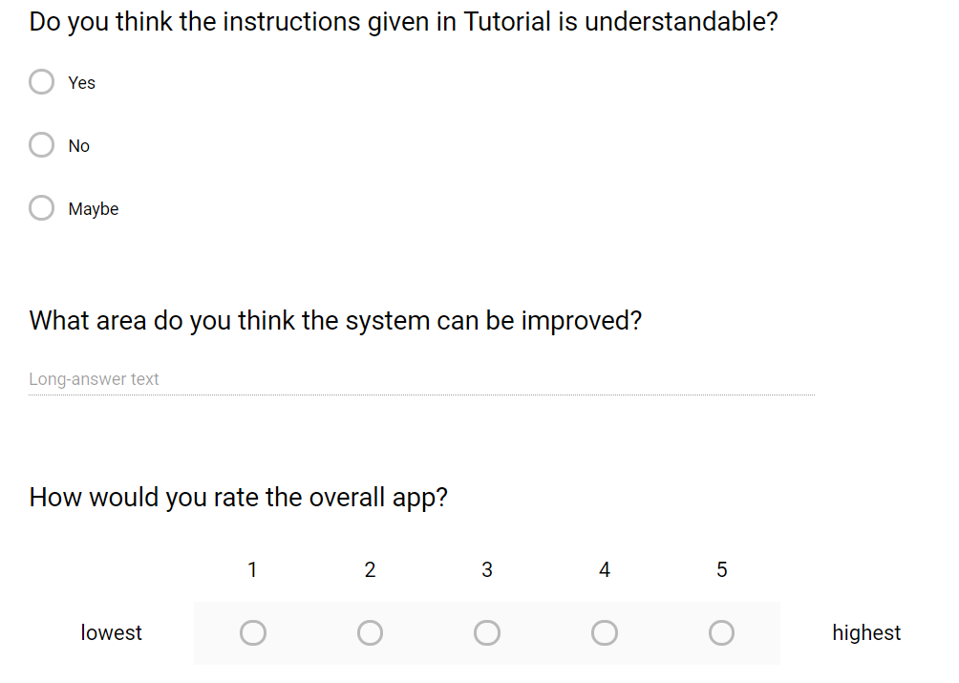

Figure 6‑3 User evaluation form 3

### Evaluation Form Response

After evaluating 20 people, the responses are shown as the figures below.

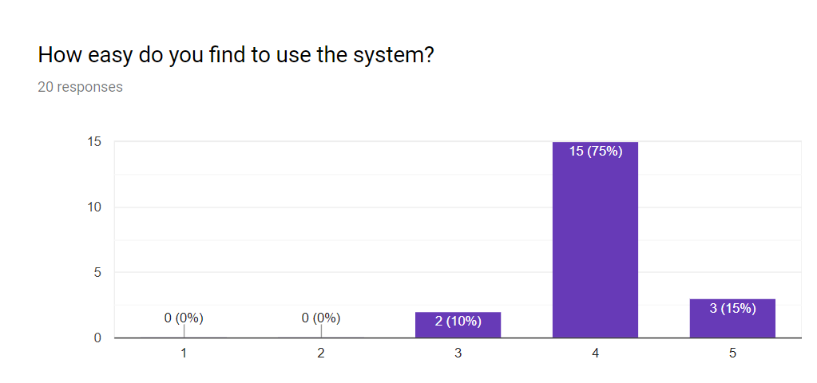

Figure 6‑4 Question 1 result

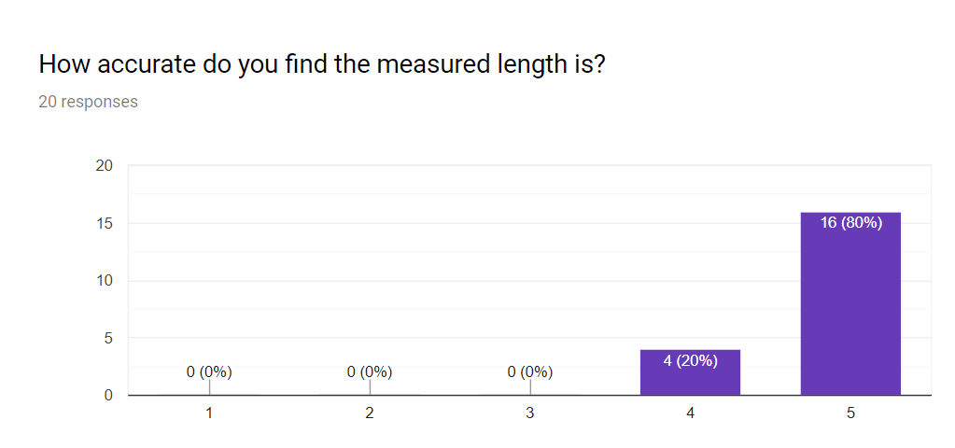

Figure 6‑5 Question 2 result

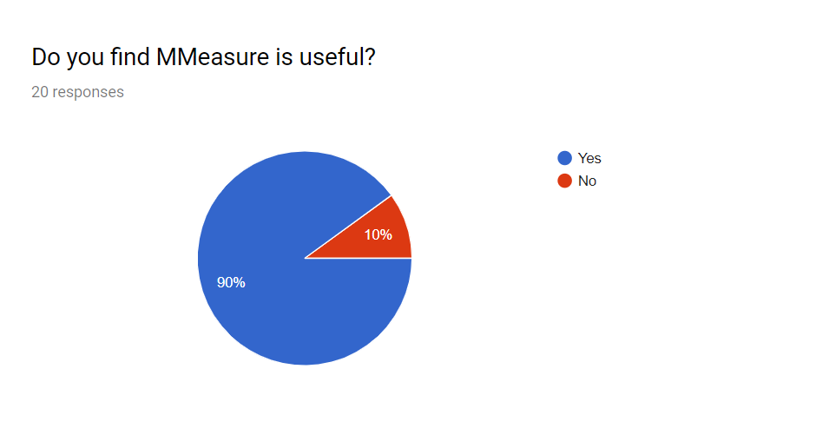

Figure 6‑6 Question 3 result

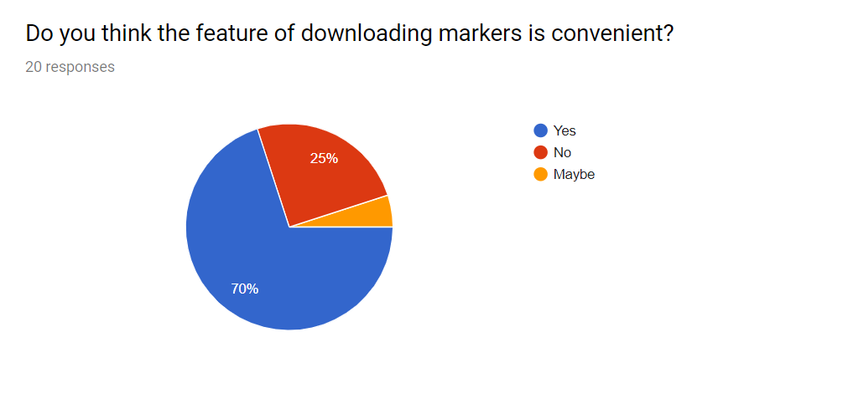

Figure 6‑7 Question 4 result

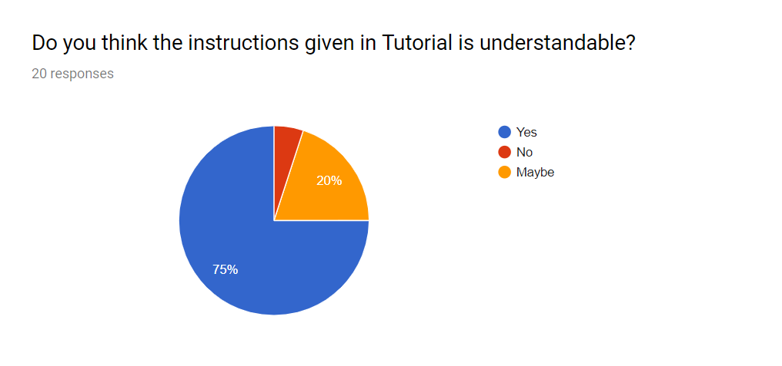

Figure 6‑8 Question 5 result

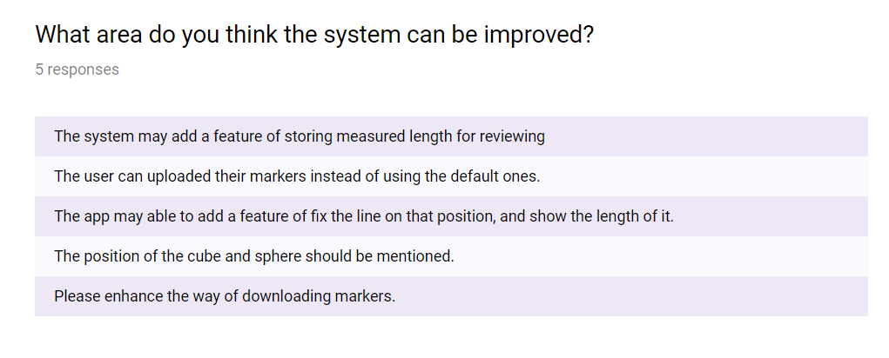

Figure 6‑9 Question 6 result

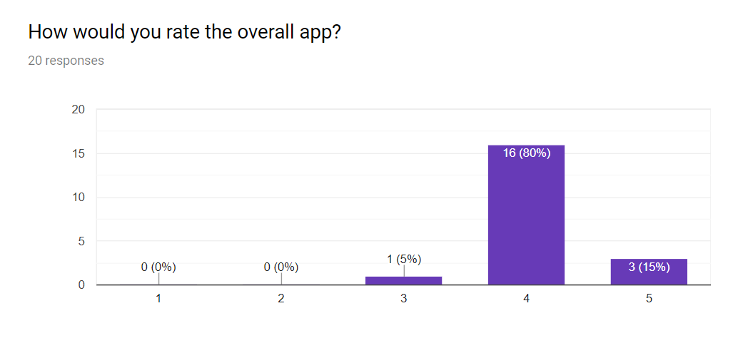

Figure 6‑10 Question 7 result

In overall, the responses are quite positive. The people are satisfying about the accuracy of the app, and they find that the app is easy to use. In Figure 6‑10, most of the people rate the app above 4. However, there are a few difficulties of downloading the markers, which the method and the effort of printing the markers are probably the reason of causing troubles. The responses about playing tutorial are interesting, that the people may not try that part during the testing, and therefore choose option of “Maybe”.

# Conclusion

In the first phase, the project succeeds in building a measuring app with high accuracy from nothing to a prototype.

During the development process, I have achieved designing a prototype with the basic functions. It works well in Android devices, the markers are able to be detected and superimposed while the calculation for the measurement is well performed. The link between two markers has no glitches. Throughout the process of developing the app, the advantages and disadvantages of SDK are explored and the research determined the final decision of using Vuforia. The researches support and provide more understanding about how an AR app works. In the end, the result is satisfying, as the algorithm of calculating length is chosen and implemented well.

## Problem Encountered

The development processes are very challenging, as there is no reference about the concept of building a measuring app in phone devices using Vuforia SDK. Although Google and Apple had published their own measuring application, the device requirements are very high due to the specs of the devices. In order to solve the problems, I am able to have many communications with other professionals. Some ideas came out when seeking advice and brainstorming with them helps a lot for the progression.

## Limitation/ Future Work

Basically, an AR app developed by using Vuforia can be published in both iOS and Android devices. However, there are some difficulties if the app published on iOS platform as the user need to have actions of jail breaking the device. Besides, Vuforia SDK does not support builds on any desktop device, only the devices intended for VR/AR capabilities are able to run it. If the developer insisted of opening the app, it can be tested in Unity Editor mode with web camera attached. Apart from that, the markers should be place in a flat surface in order to have better alignment.

However, there are still a lot of improvements can be done in the future. As mentioned above, the feature of multiplatform is one of the possible enhancements that allow more users to use. Besides, an area can be drawn by storing the length of each side, and therefore form a graph of showing the result of the area. The set of markers can be added to handle further distance away from camera. Nevertheless, users may upload their own markers with rectangle size and enter the width and height.

In the end, a package of importing the project and the project assets are zipped and uploaded at Github and Google Cloud. If there is anyone interested to take over the project, please contact Dr. Ian Chai for further process.

# Reference

Akanksha. (25 September, 2014). *Developing Android Augmented Reality Applications*. Retrieved from DeveloperIQ: http://developeriq.in/articles/2014/sep/25/developing-android-augmented-reality-applications/

Amin, D. & Govilkar, S. (2015). Comparative study of augmented reality SDKs. *International Journal on Computational Science & Applications*, 5(1), 11-26.

Azuma, R. T. (1997). A survey of augmented reality. *Presence: Teleoperators & Virtual Environments*, 6(4), 355-385.

Azuma, R., Baillot, Y., Behringer, R., Feiner, S., Julier, S., & MacIntyre, B. (2001). Recent advances in augmented reality. . *NAVAL RESEARCH LAB WASHINGTON DC*.

Craighead, J., Burke, J., & Murphy, R. (2008). Using the unity game engine to develop sarge: a case study. *In Proceedings of the 2008 Simulation Workshop at the International Conference on Intelligent Robots and Systems*, (IROS 2008).

Crider, M. (16th March, 2018). *What Is Fuchsia, Google’s New Operating System?* Retrieved from How-To Geek: https://www.howtogeek.com/345777/what-is-fuchsia-googles-new-operating-system/

Ibañez, A. S., & Figueras, J. P. (2013). Vuforia v1. 5 SDK: Analysis and evaluation of capabilities. *Master in Science in Telecommunication Engineering & Management*, 5-8.

Kochi, N., Ito, T., Noma, T., Otani, H., Nishimura, S., & Ito, J. . (2003). PC-based 3D image measuring station with digital camera an example of its actual application on a historical ruin. *INTERNATIONAL ARCHIVES OF PHOTOGRAMMETRY REMOTE SENSING AND SPATIAL INFORMATION SCIENCES*, 34(5/W12), 195-199.

Loser, R., Luhmann, T., & PMU, L. H. (1993). he programmable optical 3d measuring system pom-applications and performance. *International Archives of Photogrammetry and Remote Sensing,*, 29, 533-533.

Osborne, J. (1st September, 2018). *Google Fuchsia release date, news and rumors*. Retrieved from techradar: https://www.techradar.com/news/google-fuchsia

Rouse, M. (August, 2005). *Prototyping Model*. Retrieved from SerachCIO: https://searchcio.techtarget.com/definition/Prototyping-Model

Teegarden, C. (17 May, 2018). *Google's New Cross Platform Tool: Flutter – What's The Catch?* Retrieved from CapTech: https://www.captechconsulting.com/blogs/googles-new-cross-platform-tool-flutter-whats-the-catch

Voicu, A., Gheorghe, G. I., & Badita, L. (2013). 3d measuring of complex automotive parts using video-laser scanning. . *Google Scholar*.

# Appendices

## Appendix A: Commercialization Proposal

**1. Executive Summary**

The commercialization proposal contains 4 pages of information and analysis of the app. This includes the market and business analysis of the app, the strengths and weakness, and the project outcomes.

**2. Market Analysis**

The target and potential customers are the people who involved in construction of building industry. Besides, the people who planned to have DIY for his house are also one of the target customer.

**3. Problem Statement**

The operating on the several equipment has some potential in causing some measurement errors or observational errors Besides, the current stage of the AR measuring app is not perfect as it is lacking of the accuracy on the result.

**4. Unique Value Proposition**

The basis of MMeasure is using Image Detection in AR techniques. Image Detection may decrease the rate of showing inaccurate result since it does not use the gyroscope installed inside phone devices.

**5. Objectives**

* Provides a high accuracy and portable measuring app which the accuracy is below ±1cm.
* Provides a measuring app that is simple to use, with understandable instructions given.
* The measuring app will not require high hardware requirements of phone devices

**6. Methods and Scope of Work**

With Image Detection techniques, the system will able to calculate the distance between camera and the image targets based on the image targets’ scale, and simulates the real world environment. This allows the measured result is same as the real world ones. A line is drawn as the measured length for user to verify, and the user may change the unit of the measured length as well.

**7. Business Model**

Financial Snapshot (Income Statement)

|  |  |  |  |  |  |
| --- | --- | --- | --- | --- | --- |
|  | Year 1 | Year 2 | Year 3 | Year 4 | Year 5 |
| Revenue (RM) | 5000 | 10000 | 20000 | 35000 | 55000 |
| Research & Development (RM) | 800 | 800 | 800 | 800 | 800 |
| Operating Expenses (RM) | 20000 | 20000 | 20000 | 25000 | 25000 |
| Operating Income (RM) | 0 | 0 | 5000 | 10000 | 15000 |
| Income before Tax (RM) | -5000 | 0 | 5000 | 10000 | 15000 |
| Income Tax Expense (RM) |  |  | 1000 | 1670 | 2340 |
| Net Income (RM) | -5000 | 0 | 4000 | 8330 | 12660 |

The business model of the app will collect 10% profit of each sale. Apart from that, the app will have advertising fees to some social networks.

**8. Milestones and Key metrics**

Milestones 1: Publish the system in iOS platform

This milestone will allow the range of user base get expanded. The estimated time of achieving the milestone will be within 1 month, with sufficient budget given.

Milestone 2: Expand the app coverage to nearby countries (Singapore, Indonesia) App Store.

The milestone will allow the business to gain more profits with larger user base from different countries. The estimated time of achieving it will be 9 months with appropriate fund invested.

**9. Project Outcome**

The outcome of the project will benefit the target customers by reducing the effort of bringing various measurement equipment and ease their loads. Furthermore, the company invested will gain a higher popularity and impression of producing high accuracy result in measuring length among the community.

**10. Strength, Weakness, Opportunity, and Threat (SWOT) analysis**

**Strengths:**

The strength of the app is the high accuracy rate of the result. There are a few apps exist currently, but the base technique is different with this project and the hardware requirements are higher. This allows MMeasure to have advantages in terms of market to the app.

**Weaknesses:**

The weakness of the app is the method of downloading the markers. The steps require a few efforts, but the markers play the most important in the app. This may cause users to change another app.

**Opportunities:**

The smartphone users who uses lower hardware requirements doesn’t have sufficient resources of using existed measuring app. It seems to be an opportunity to the app as it provides a platform to enhance they measurement experience.

**Threats:**

The current competitors of the app are Measure published by Google, Measure published by Apple, AirMeasure and other measuring apps. However, these app are only available for selected phone devices, therefore our app stands out in the market with other unselected phone devices users.

## Appendix B: Turnitin Report, Downloadable File & Source Code

### Turnitin Report



### PDF File

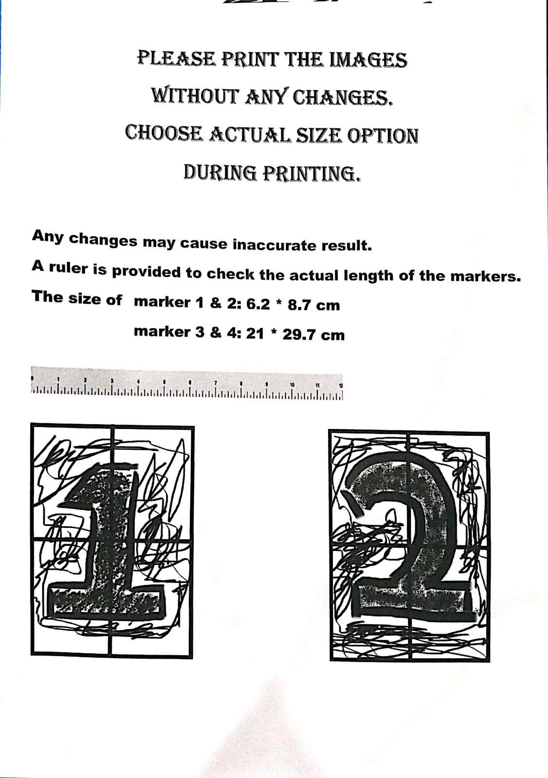

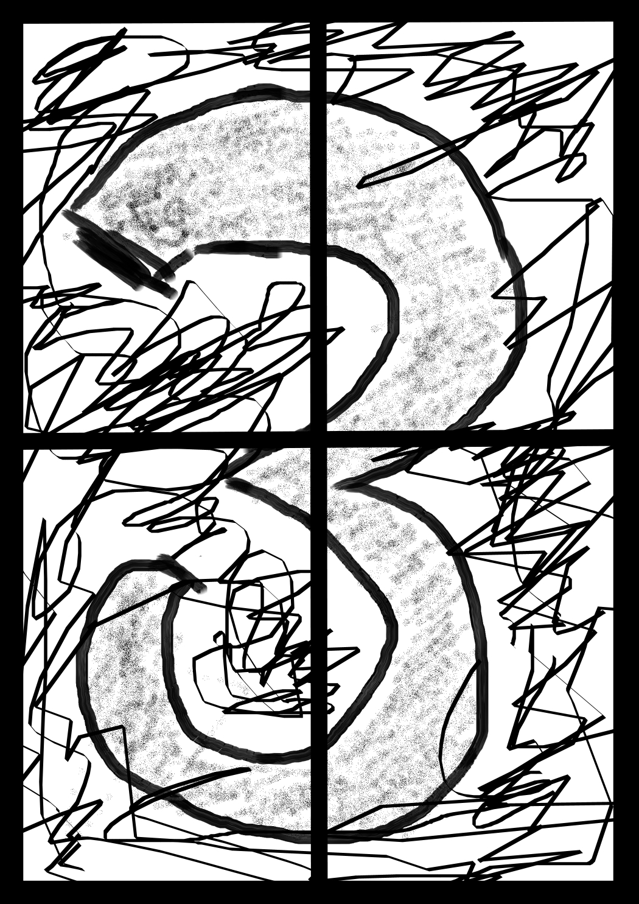

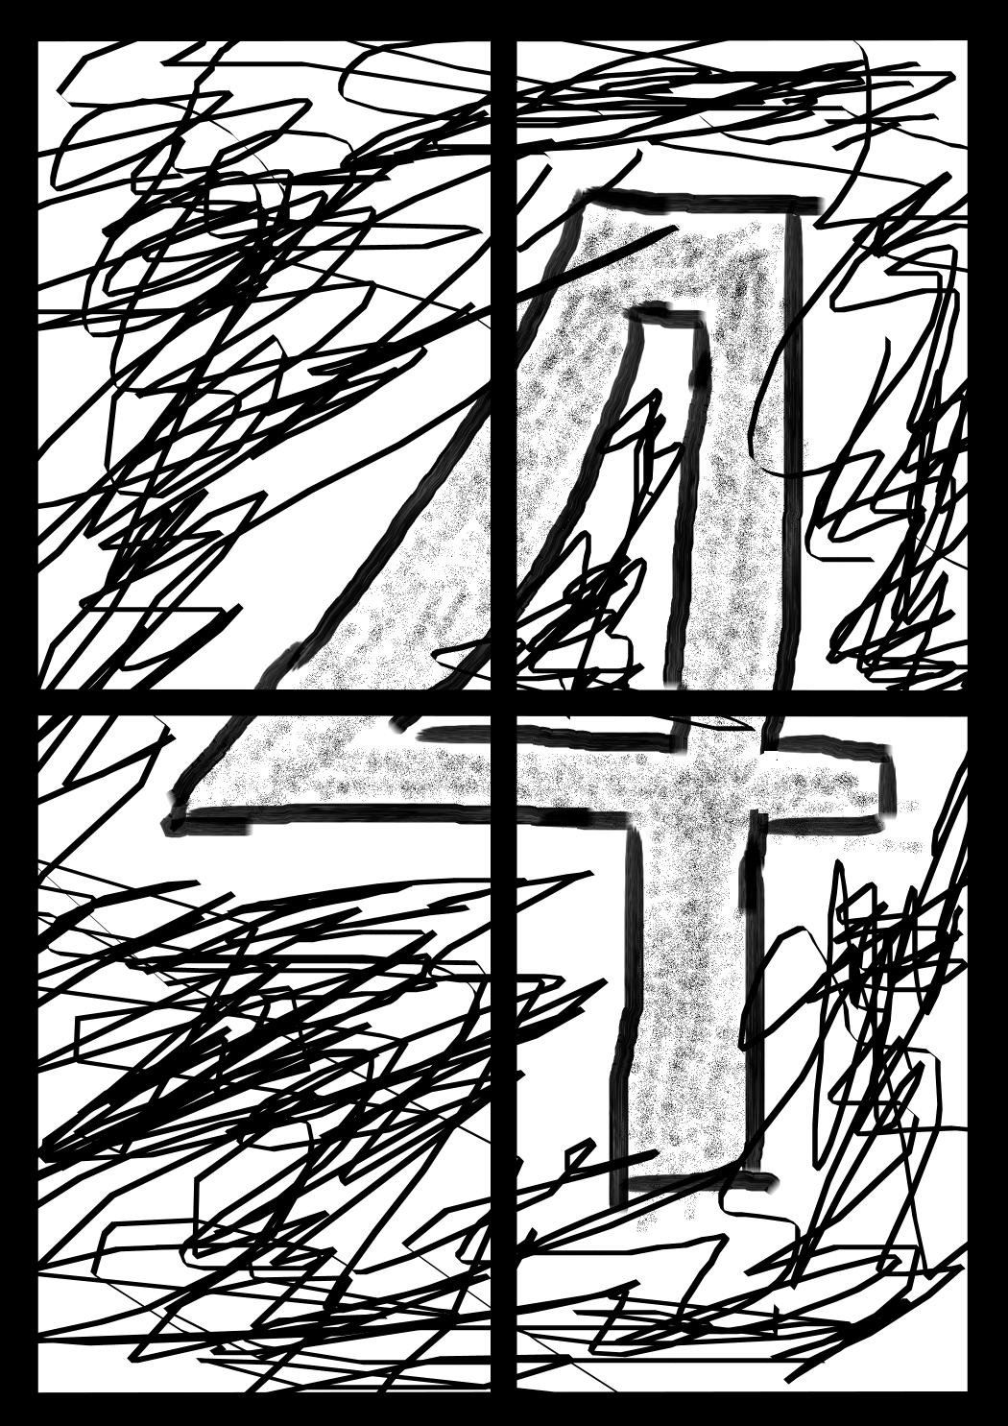

### Source Code

#### Position.cs

using UnityEngine;

using UnityEngine.UI;

using System.Collections;

using TMPro;

public class Position : MonoBehaviour

{

public GameObject object1, object2;

public TextMeshProUGUI pos_x;

public TextMeshProUGUI pos_y;

public TextMeshProUGUI pos_z;

public TextMeshProUGUI pos2_x;

public TextMeshProUGUI pos2_y;

public TextMeshProUGUI pos2_z;

public int unit;

public Vector3 pos, pos2;

void Start()

{

unit = 0;

}

void Update()

{

pos = object1.transform.position;

pos_x.text = "1_X:" + pos.x.ToString("F2");

pos_y.text = "1_Y:" + pos.y.ToString("F2");

pos_z.text = "1_Z:" + pos.z.ToString("F2");

pos2 = object2.transform.position;

pos2_x.text = "2_X:" + pos2.x.ToString("F2");

pos2_y.text = "2_Y:" + pos2.y.ToString("F2");

pos2_z.text = "2_Z:" + pos2.z.ToString("F2");

}

}

//unit is a flag of changing the units, the following numbers will

//be a trigger to change the curent unit.

// 0 = cm,

// 1 = m,

// 2 = inch,

// 3 = foot

#### Distance_text.cs

using UnityEngine;

using UnityEngine.UI;

using System.Collections;

using TMPro;

public class Distance_text : MonoBehaviour

{

public Position change;

public TextMeshProUGUI distance;

public float total_Distance;

void Update()

{

float distanceX = change.pos2.x - change.pos.x;

float distanceY = change.pos.y - change.pos2.y;

float distanceZ = change.pos.z - change.pos2.z;

total_Distance = Mathf.Sqrt(distanceX * distanceX + distanceY * distanceY + distanceZ * distanceZ);

distance.text = "Distance:" + total_Distance.ToString("F2") + "cm";

}

}

#### ImageTrackableBehaviour.cs

using UnityEngine;

using Vuforia;

//Attach to the image tracker

public class ImageTrackableBehaviour : MonoBehaviour, ITrackableEventHandler

{

public int counter_image;

private TrackableBehaviour trackableBehaviour;

void Start()

{

trackableBehaviour = GetComponent<TrackableBehaviour>();

if (trackableBehaviour)

trackableBehaviour.RegisterTrackableEventHandler(this);

}

public void OnTrackableStateChanged(

TrackableBehaviour.Status previousStatus,

TrackableBehaviour.Status newStatus)

{

if (newStatus == TrackableBehaviour.Status.DETECTED ||

newStatus == TrackableBehaviour.Status.TRACKED ||

newStatus == TrackableBehaviour.Status.EXTENDED_TRACKED)

counter_image = 1;

else

counter_image = 0;

}

}

#### Line_dis.cs

using System.Collections;

using System.Collections.Generic;

using UnityEngine;

public class Line_dis : MonoBehaviour {

private LineRenderer line_render;

public Transform Cube;

public Transform Sphere;

public ImageTrackableBehaviour trackable_status, trackable_status2;

Vector3 disable = new Vector3(0, 0, 0);

void Start () {

}

void Update () {

line_render = GetComponent<LineRenderer>();

if (Cube != null || Sphere != null)

{

if (trackable_status.counter_image == 1 && trackable_status2.counter_image == 1)

{

line_render.SetPosition(0, Cube.position);

line_render.SetPosition(1, Sphere.position);

}

else

{

line_render.SetPosition(0, disable);

line_render.SetPosition(1, disable);

}

}

}

}

#### Unit_m

using System.Collections;

using System.Collections.Generic;

using UnityEngine;

using UnityEngine.UI;

public class Unit_m : MonoBehaviour

{

public Distance_text dis_txt;

public Position change;

float _M = 100, _INCH = 2.54f, _FOOT = 30.48f;

float change_unit;

void Update()

{

unit_calculation();

}

public void unit_calculation()

{

if (change.unit == 0 )

{

}

else if (change.unit == 1)

{

change_unit = dis_txt.total_Distance / _M;

dis_txt.distance.text = "Distance:" + change_unit.ToString("F2") + "m";

}

else if (change.unit == 2 )

{

change_unit = dis_txt.total_Distance / _INCH;

dis_txt.distance.text = "Distance:" + change_unit.ToString("F2") + "in";

}

else if (change.unit == 3)

{

change_unit = dis_txt.total_Distance / _FOOT;

dis_txt.distance.text = "Distance:" + change_unit.ToString("F2") + "ft";

}

}

public void change_to_m()

{

change.unit = 1;

}

public void change_to_inch()

{

change.unit = 2;

}

public void change_to_foot()

{

change.unit = 3;

}

public void change_to_cm()

{

change.unit = 0;

}

}

#### ChangeScene.cs

using System.Collections;

using System.Collections.Generic;

using UnityEngine;

using UnityEngine.SceneManagement;

public class ChangeScene : MonoBehaviour {

protected static string PreviousScene = "";

public void changeScene (string sceneName)

{

PreviousScene = SceneManager.GetActiveScene().name;

SceneManager.LoadScene(sceneName);

}

public void BackFromTutorial ()

{

SceneManager.LoadScene(PreviousScene);

}

}

#### Download.cs

using System.Collections;

using System.Collections.Generic;

using UnityEngine;

public class download : MonoBehaviour

{

public void download_marker()

{

Application.OpenURL("https://warm-ridge-70125.herokuapp.com/hyperlink.html");

}

}

#### Exit.cs

using System.Collections;

using System.Collections.Generic;

using UnityEngine;

public class Exit : MonoBehaviour

{

public void ExitApp()

{

Application.Quit();

}

}

#### Hyperlink.html

<!DOCTYPE html>

<html>

<body>

<h2>Download PDF Files</h2>

<p><a href="https://warm-ridge-70125.herokuapp.com/image_for_print.php">Click this for download</a></p>

</body>

</html>

#### Image_for_print.php

<?php

header("Content-disposition: attachment; filename=image_for_print.pdf");

header("Content-type: application/pdf");

readfile("image_for_print.pdf");

?>

## Appendix C: Meeting Log